MINISTRY OF EDUCATION AND TRAINING MINISTRY OF DEFENCE
MILITARY INSTITUTE OF TRADITIONAL MEDICINE

LÊ HỒNG TUYẾN

AN EXPERIMENTAL AND CLINICAL
RESEARCH ON THERAPEUTIC EFFECTS
OF HT ON TYPE 2 DIABETES TREAMENT

Major : Traditional Medicine
Code : 62720201

SUMMARY OF PhD DISSERTATION

HANOI – 2016
THE STUDY WAS DONE AT: MILITARY INSTITUTE OF TRADITIONAL MEDICINE

Instructors:
1. Assoc, PhD. NGUYEN MINH HA
2. PhD. DO THI MINH THIN

Reviewer 1: PhD. Associate Professor. Do Thi Phuong

Reviewer 2: PhD. Associate Professor. Hoang Trung Vinh

Reviewer 3: PhD. Associate Professor. Nguyen Trong Thong

The dissertation will be defensed at PhD Committee, Military Institute of Traditional Medicine

Find more information on this thesis at:
- Library of Military Institute of Traditional Medicine
- National library
- National Library of medical information

Part A: INTRODUCTION

1. BACKGROUND
Diabetes is an endocrine disease, is increasing in the world as well as in Vietnam, the death rate ranks third after cancer disease and cardiovascular disease. In 2011, the International Diabetes Federation (IDF) has announced the world has 366 million diabetes patients, the number is forecasted to reach up to 552 million in 2030. According to the epidemiological study of Hospital of Endocrinology (2014, Hanoi) the rate of diabetes patients among adults increased 5-6 times than before (5,42%).
In Vietnam nowadays, most diabetes drugs must be costly imported, the treatment course is a lifetime-long process, those are difficulties for patients. Seeking for a new medication, which is effective in treatment, less toxic and available in Vietnam, thus, is a necessary and practical work.
HT formulas was formed from the results of modeling on experimental diabetes and clinical study, and inheritance of medical literature. In order to have sufficient scientific basis to declare the effectiveness of the remedies, we conducted: "An experimental and clinic research on therapeutic effects of HT on type 2 diabetes treatment”
2. OBJECTIVES
1. Studying and evaluating the toxicity and hypoglycemic effect of HT on experimental animals.
2. Studying the hypoglycemic of HT in clinic and comparing its effects to other diabetes drugs.
PRACTICAL SIGNIFICANCE AND NEW CONTRIBUTIONS
The dissertation is a scientific work carried out in a systematic way on a product of traditional medication in the type 2 diabetes treatment.
The study results showed that the medication has an excellent safety, hypoglycemic effect, adjusts dyslipidemia in experiments and in mild and moderate type 2 diabetes patients, the undesired effects have not been seen. The study on HT medication on type 2 diabetes treatment contributes to clarify the theory of traditional medicine and to gradually modernize the traditional medicine. So the study has both scientific and practical meanings. Our country has a long history of using traditional medicine, the results of the thesis, thus, contribute new and extremely practical values to its heritage.
THE STRUCTURE OF THE THESIS
Apart from the background and conclusion, the thesis includes four chapters:
Chapter 1: Overview, 39 pages
Chapter 2: Objectives and methodology, 20 pages
Chapter 3: Findings, 38 pages
Chapter 4: Discussion, 29 pages
The thesis has 56 tables, 4 charts, 14 photos, 2 diagrams, 3 appendixes, 146 references (53 in Vietnamese, 65 in English, and 28 in Chinese).

Part B: CONTENT
CHAPTER 1: OVERVIEW

1.1. DEFINITION, PATHOLOGY, DIAGNOSIS STANDARD AND TYPE 2 DIABETES TREATMENT UNDER MODERN MEDICINE
* Definition and classification of diabetes mellitus
Definition of Committee of Diabetes Diagnosis and Classification (United States): “Diabetes is a group of metabolic diseases characterized by hyperglycemia resulting from defects in insulin secretion, insulin action, or both. The chronic hyperglycemia of diabetes is associated with long-term damage, dysfunction, and failure of different organs, especially the eyes, kidneys, nerves, heart, and blood vessels”.
* The pathogenesis of type 2 diabetes
The pathogenesis of type 2 diabetes relates to relative insulin deficiency, mainly due to abnormalities in insulin secretion and insulin resistance. Insulin secretion and insulin resistance are closely related to each other and occur before the appearance of clinical symptoms of diabetes (pre-diabetes). Insulin resistance is common in type 2 diabetes patients who are not overweight, whereas insulin resistance is the major reasons in type 2 diabetes patients with obesity.
* Type 2 diabetes treatment
The treatment strategies include lifestyle changes (diet and exercise) and medications. Type 2 diabetes drugs currently focus on groups: drugs which stimulate insulin secretion (sulfonylureas, meglitinid), which increase sensitivity to insulin of target cells (biguanide derivatives, thiazolidinedion group), which inhibit α glucosidase enzyme, and which inhibit copper transporting Na+/glucose in the kidney tubules.
1.2. CAUSES, PATHOLOGY, SYPTOMS, AND TREATMENT PRINCIPLES OF TYPE 2 DIABETES UNDER TRADITIONAL MEDICINE
Traditional medicine does not have the name for diabetes, the symptoms of the category of thirst consumptive disease: feeling thirsty, feeling hungry, urinating often, weight loss, fatigue, and sweet urinating are considered as main symptoms of this disease.
The main causes of consumptive thirst are the innateness imbalance, wuxing insufficiency, mental stimulation, emotional disharmony, high fat and sugar diet, or obesity.
The basic of consumptive thirst, yin deficiency – heat dryness, directly affect lungs, spleen, stomach and kidney. Therapies commonly used are: clearing heat lungs, nourishing yin and clearing lungs, nourishing yin and kidney, promoting production of body fluid and quenching thirst.
1.3. HT MEDICATION
- Ingredients
No | Ingredients | Content
1 | Radix ginseng | 0,80 g
2 | Radix Ophiopogonis japonica | 1,70 g
3 | Fructus Schisandrae | 0,35 g
4 | Pericarpium Citri reticulatae | 0,45 g
5 | Radix Puerariae Thomsonii | 1,70 g
- Effects: nourishing yin, promoting the production of body fluid and quenching thirst.
- Findings in modern studies showed that the ingredients of this medication have hypoglycemic effects on experiment.
- The medication used to treat patients with consumptive thirst (diabetes) has initially hypoglycemic effects and improve some clinical symptoms such as feeling thirsty, feeling hungry, urinating often, weight loss, fatigue.

CHAPTER 2:
MATERIALS, SUBJECTS AND METHODOLOGY

2.1. MATERIALS
Researched medication
Medication is processed and packed at Department of Pharmacy – Military Institute of Traditional Medicine, under the standards of National Institute of Drug control. Medication is finely powdered in sachet of 5g, 20 sacs/ box.
2.2. SUBJECTS
2.2.1. Experimental trial
Swiss mice, 60 in quantity, both male and female, healthy, weight 20 - 22g, supplied by National Institute of Hygiene and Epidemiology. Wistar white rats, 80 in quantity, all male, average weight 200 ± 20g, supplied by Breeding Department (Military Academy of Medicine). Newzealand rabbits strain, 30 in quantity, white, weight 1.8-2.2kg, supplied by Center of Researching on Goats and Rabbits.
2.2.2. Clinical research
120 adult in-patients (>18yrs) were diagnosed with mild or moderate type 2 diabetes, they volunteerly joined the study, under diabetes diagnostic standard by WHO (2002) and their disease severities were classified according to Thai Hong Quang, 2001. Patients were treated at Military Institute of Traditional Medicine.
* Patient selecting basics:
According to modern medicine: In this study, patients were selected in both sexes, diagnosed with type 2 diabetes under diabetes diagnostic standard by the American Diabetes Association (WHO) in 2002 and their disease severities were classified according to Thai Hong Quang, 2001.
According to traditional medicine: Based on a diabetes assessing scale through: observing, listening, questioning, and palpating; disease is believed to belong to different parts of the abdomen: upper, middle and lower abdomen.
* Patient eliminating basics:
According to modern medicine:
- Severe type 2 diabetes patients.
- Patients using diabetes drugs.
- Patients suffering acute complications: acidosis coma - ketones, coma increases osmotic pressure, acute infections (urinary tract infections, pneumonia, etc.) and suffering other diseases such as hematuria macroscopic.
- Patients with liver failure, kidney failure, heart failure, limb amputation.
- Patients with history of myocardial infarction, cerebral stroke.
- Patients with treatment-resistant hypertension.
- Patients with endocrine diseases (Basedow, Cushing syndrome ...).
- Patients suffering other severe diseases
- Patients did not agree to participate in the research.
According to traditional medicine: patients with yin and yang deficiency
2.3. METHODOLOGY
2.3.1. Research on acute and sub-chronic toxicity and hypoglycemic effect of HT medication on experimental animals
* Study on acute, sub-chronic toxicity
- Acute toxicity is defined on white mice through oral administration under Litchfield - Wilcoxon. Mice drinking HT (after being fasted for 12 hours) at doses from 10.0g/kg to 50.0g/kg. Mice health condition and death number are observed in different groups in 72 hours.
- Sub-chronic toxicity trial: the trial conducted in rabbits at doses of 1.2 g/kg/day (human equivalent dose - HED) and the dose of 3,6g/kg/day (3 HED) in 4 weeks. Body weight, eating and sleeping habits, movement, liver and kidney gastrointestinal, hematological, biochemical function, and histopathology of experimental animals after the treatment were compared with control group (drinking distilled water).
* Experimental trial on hypoglycemic effects
White rats were caused type 2 diabetes by high fat diet and STZ injection.
Rats were divided into 5 groups (10 rats in each group): 4 groups were given STZ injection.
- Group 1 (model control): no STZ injection
- Group 2 (negative control): oral saline
- Group 3 (positive control): oral Amaryl 0,56mg/kg
- Group 4 (study 1): HT 2,8g/kg (HED)
- Group 5 (study 2): HT 8,4g/kg (3 HED).
On 10th day, an hour after medication taking, the blood glucose of rats in 4 groups was tested. Glycemic index, pancreatic islet histopathology, triglycerides, HDL-C, LDL-C, total cholesterol were evaluated, and the data was compared between groups at different times.
2.3.2. Clinical research
The research was a prospective random control clinical trial, 120 patients under the study requirement were divided into 2 groups.
- Group 1 (study group) 80 patients: HT 10g/time, 2 times / day. 30 minutes after meals.
- Group 2 (control group), 40 patients: Amaryl 4 mg x 02 capsules/day. In the morning and afternoon, 30 minutes before meals.
Patients suffering other diseases as hypertension, dyslipidemia were prescribed western medicine. Treatment time was tested when fasting and 2 hours postprandial and the data was evaluated after 4 weeks of treatment.
* Data evaluation
- According to Modern Medicine:
Table 2.7 Target indicators in patients with type 2 diabetes of Vietnam Endocrinology - Diabetes Association, 2011
Target indicators | Unit | Good | Pretty good | Poor
Glucose fasting blood glucose | mmol/l | 4,4 – 6,1 | 6,2 – 7,0 | > 7,0
h2h postprandial blood glucose | mmol/l | < 10 | 10 – 15 | >15
HbA₁c | % | < 6,5 | ≤ 75 | > 7,5
Blood pressure | mmHg | < 130/80 | 130/80 - 140/90 | > 140/90
BMI | kg/m² | 18,5 - 23 | 18,5 - 23 | ≥ 23
Cholesterol TP | mmol/l | < 4,5 | 4,5 - ≤ 5,2 | ≥ 5,3
HDL-c | mmol/l | > 1,1 | ≥ 0,9 | < 0,9
Triglycerid | mmol/l | < 1,5 | 1,5 - ≤ 2,2 | > 2,2
LDL-c | mmol/l | < 2,5 | 2,5 – 3,4 | ≥ 3,4

- According to traditional medicine:
- Good: all or almost symptoms are successfully treated, reduction score ≥ 90%.
- Pretty good: symptoms markedly are improved, reduction score ≥ 70%.
- Average: Symptoms are positively changed, reduction score ≥ 30%.
- Poor: symptoms do not improve, or even get worse, reduction score is under 30%.
- Data assessment criteria:
- Good: all or almost symptoms are significantly improved, reduction score ≥ 70%. Fasting blood decreases to the normal limit (≤ 7mmol / l) or decrease > 40% in comparison with before treatment.
- Pretty good: symptoms are improved, reduction score ≥ 30% reduction. Fasting blood glucose decreases, but does not reach the normal limit (≤ 7 mmol / l) and decreases > 20% in comparison with before treatment.
- Moderate: Symptoms unsatisfactorily change, reduction score <20%. Fasting blood glucose decreases, but does not achieve treating effect.
- Poor: symptoms do not improve, or badly change, reduction score > 10%. Fasting blood glucose does not fall or even raise.
* Comparison on therapeutic effects between traditional medicine and modern medicine.
* Observation of undesirable effects on clinical study and on liver and renal function and hematological parameters test
Symptoms such as nausea, vomiting, abdominal pain, dyspepsia, rash ...
2.4. DATA PROCESSMENT
The data were processed by the method of biomedical statistics on the computer by SPSS 20.0 software. T-test student algorithm was used to compare 2 average values. χ² test was used to compare data before and after the treatment. The difference was statistically significant with p ≤ 0,05.
Chapter 3
FINDINGS

3.1. FINDINGS ON TOXICITY AND HYPOLYCEMIC ASSESSMENT EFFECT OF HT ON EXPERIMENTAL ANIMALS
3.1.1. Findings on acute toxicity (LD50)
Mice were given doses from 10,0g/kg to 50,0g/kg (12 times of maximum recommended dose) toxicity was not seen in 7 days of observation. Lethal dose 50% has not been determined yet.
3.1.2. Findings on sub-chronic toxicity
Dose 1,2g/kg/day (HED) and dose of 3,6g/kg/day (3 HED), haematological indicators, liver and kidney blood biochemistry and histopathology did not change during 4 weeks of constinuously medication administration.
3.1.2. Findings on hypoglycemic effect on experimental animals
3.1.2.1. Findings on mice weight
Table 3:16. Findings on mice weight on control groups (g)
Time  Groups | Before using hight-fat diet (A) | After using hight-fat diet (B) | After STZ injection (C) | After treatment (D)
Model control group (1) | 181,0 ± 14,3 | 246,0 ± 19,7 | 261,7 ± 22,1 | 280,4 ± 29,2
Negative control group (2) | 179,6 ± 15,1 | 251,9 ± 18,3 | 250,4 ± 18,9 | 240,2 ± 20,3
Positive control group (3) | 181,8 ± 18,1 | 249,4 ± 21,3 | 248,6 ± 20,7 | 250,1 ± 23,6
HT low dose group (4) | 183,6 ± 16,5 | 251,2 ± 22,1 | 252,3 ± 21,4 | 257,8 ± 21,6
HT high dose group (5) | 180,2 ± 13,7 | 250,3 ± 18,0 | 249,7 ± 19,5 | 256,1 ± 24,4
(p_{A1-B1,} p_{A2-B2,}p_{A3-B3,}p_{A4-B4,}p_{A5-B5}<0.01)
Reviews: After 4 weeks of using high-fat diets, all groups significantly increased weight (p <0.01). After 7 days of STZ injection group 1 increased weight, but the difference was not statistically significant (p> 0,05). Groups 2, 3, 4, 5 did not change their weight.
After the treatment, body weight of group 3 slightly changed. Group 4, 5 increased, group 2 decreased, the difference was not statistically significant (p> 0,05).
3.1.2.2. Findings on blood glucose tests
Table 3.17. Findings on blood glucose tests (mmol / l)
Time  Groups | Before using hight-fat diet (A) | After using hight-fat diet (B) | After STZ injection (C) | p
Model control group (1) | 4,2 ± 0,5 | 4,6 ± 0,6 | 4,5 ± 0,6 | >0.05
Negative control group (2) | 4,5 ± 0,4 | 13,9 ± 0,8 | 13,4 ± 1,1  - 3,6% | p_{A-B} <0,001;  p_{B-C} >0,05
Positive control group (3) | 4,4 ± 0,6 | 13,5 ± 1,2 | 9,1 ± 1,4  - 32,6% | p_{A-B} <0,001;  p_{B-C} <0,01
HT low dose group (4) | 4,5 ± 0,6 | 13,6± 1,2 | 9,8 ± 0,7  - 28,0% | p_{A-B} <0,001;  p_{B-C} <0,01
HT high dose group (5) | 4,6 ± 0,7 | 13,3± 1,3 | 10,6 ± 1,1  -20,3% | p_{A-B} <0,001;  p_{B-C} <0,05
p | p_{1,2,3,4,5}>0,05 | p_{1-2,3,4,5}<0,001  p_{2,3,4,5}>0,05 | p_{1-2,3,4,5}<0,001  p_{2-3,4,5}<0,05  p_{3,4,5}>0,05
Reviews: After STZ injection, the blood glucose of group 2,3,4,5 increased, in comparison with group 1, statistical significance (p1-2,3,4,5<0,001). After treatment in negative control group: blood glucose did not change in comparison with before treatment. In positive control, HT low dose and HT high dose group: blood glucose decreased 32,6%, 28,0% and 20,3%, respectively, statistical significance (p <0,01). The difference on blood glucose reduction on HT low dose and HT high dose groups was not statistically significant (p> 0,05).
3.1.2.3. Findings on lipid values
* Findings on Cholesterol Test
Table 3.18. Findings on Cholesterol Test (mmol / l)
Time  Groups | Before treatment | After treatment | %  Change | p
Model control group (1) | 1,5 ± 0,2 | 1,5 ± 0,3 | 0 | >0,05
Negative control group (2) | 2,9 ± 0,3 | 2,8 ± 0,2 | - 3,4 | >0,05
Positive control group (3) | 2,7 ± 0,3 | 2,4 ± 0,4 | - 11,1 | >0,05
HT low dose group (4) | 2,8 ± 0,4 | 2,3 ± 0,4 | - 17,8 | >0,05
HT high dose group (5) | 2.7 ± 0.3 | 2,3 ± 0,6 | - 14,8 | >0,05
p | p_{1-2,3,4,5} <0.01 | p_{1-2,3,4,5} <0.01
Reviews: After the treatment, in the negative control group, the difference on cholesterol reduction was not statistically significant (p> 0,05). In positive control, HT low dose, and HT high dose groups, Cholesterol decreased 11,1%, 17,8% and 14,8%, respectively, the difference was not statistically significant (p> 0,05). Cholesterol in groups 2, 3, 4, 5 was higher than group 1, the difference was statistically significant (p <0,01).
*Findings on LDL-C test
Table 3.19. Findings on LDL-C test
Time  Groups | Before treatment | After treatment | %  Change
Model control group (1) | 1,1 ± 0,2 | 1,1 ± 0,5 | 0
Negative control group (2) | 1,2 ± 0,3 | 1,2 ± 0,4 | 0
Positive control group (3) | 1,2 ± 0,4 | 1,1 ± 0,3 | - 8,3
HT low dose group (4) | 1,3 ± 0,3 | 1,1 ± 0,4 | - 15,3
HT high dose group (5) | 1,2 ± 0,4 | 1,0 ± 0,3 | - 16,7
p | >0,05 | >0,05
Table 3.20. Test results HDL-C (mmol / l)
Time  Groups | Before treatment | After treatment | %  Change | p
Model control group (1) | 0,8 ± 0,2 | 0,8 ± 0,3 | 0 | >0,05
Negative control group (2) | 0,6 ± 0,3 | 0,6 ± 0,2 | 0 | >0,05
Positive control group (3) | 0,5 ± 0,4 | 0,5 ± 0,2 | 0 | >0,05
HT low dose group (4) | 0,6 ± 0,2 | 0,7 ± 0,1 | + 16,7 | >0,05
HT high dose group (5) | 0,5 ± 0,3 | 0,6 ± 0,2 | +20,0 | >0,05
p | >0,05 | >0,05
Reviews: In the negative control group, the difference on triglycerid increase was not statistically significant in comparison with before treatment (p> 0,05). In positive control, HT low dose, and HT high dose groups, triglycerid decreased 5.2%, 15% and 15,8%, respectively, the difference was not statistically significant (p> 0,05). Triglycerid in groups 2, 3, 4, 5 was higher than group 1, the difference was statistically significant (p <0,01).
3.1.2.4. Results of histopathological examination of pancreatic islet:
- Group 1 (control): There were normal pancreatic islets of normal size. The large cytoplasmics stained pale eosin fine particle form. Some cells had dark nucleus. Exocrine pancreatic had normal structure and image.
- Group 2 (oral saline group): There was degeneration of pancreatic islet; irregular cell size. Some cells of the pancreatic islets had large size, degenerative cytoplasm, and cell nucleus had bright membrane thickness. Cell nucleus was irregular and a large number was of big size.
- Group 3 (Amaryl group): There was still cell degeneration: swollen pancreas cells; irregular, thick membrane, bold eosin staining, cell cytoplasm had small bright sockets. Cell nucleus had thick membrane. Some cells had degenerated nucleus.
- Group 4 (HT low dose): There was still degeneration in some cells: The pancreatic islets were of irregular size, and there was degeneration in islet cell. Cell nucleus were in form of coagulate nucleus, strong eosin staining.
- Group 5 (HT high dose): The islet cells had large cytoplasm, with granular cytoplasm. Cell nucleus had smooth granular chromatin. Some nucleus have dark nucleus. Light cell degeneration.
3.2 RESULTS ON TYPE 2 DIABETES TREAMENT OF HT
3.2.1 Patient characteristics
3.2.1.1. Distribution of patients by age and sex
Table 3.22. Distribution of patients by age
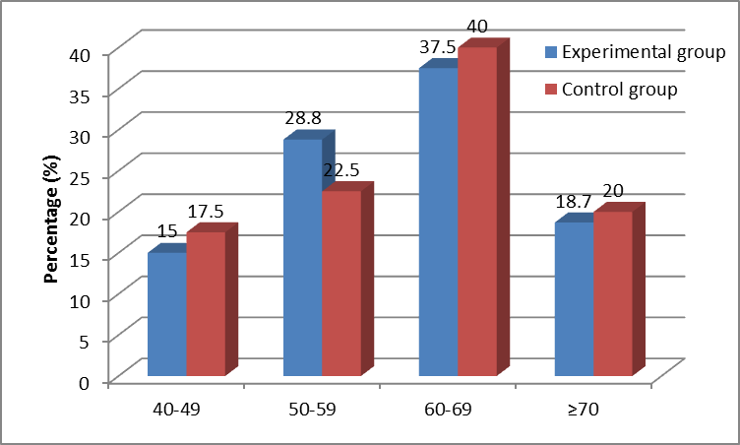
Review: The youngest is 40, the oldest is 74. Average age of study group is 62,76 ± 9,44, control group is 62,28 ± 9,0. There is no difference in the average age and the percentage of 2 experimental groups (p> 0,05).
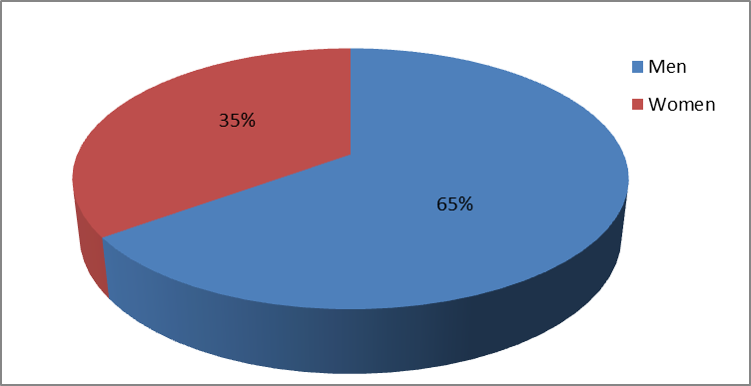
Figure 3.1. Distribution of patients by gender

3.2.2. Changes on clinical indicators before and after treatment
3.2.2.1. Functional symptoms changes
Table 3.34. Changing clinical symptoms at the studied times
Time |  | Experimental group  ¹  (n=80) |  |  | Control group²  (n=40) |  |  | p₁₋₂
 |  | Upper abdominal | Middle abdominal | Lower abdominal | Upper abdominal | Middle abdominal | Lower | p₁₋₂
Week 1 | Normal  (n, %) | 15  (18,75) | 12  (15,0) | 8  (10,0) | 7  (17,5) | 6  (15,0) | 4  (10,0) | > 0,05
Week 1 | Mild  (n,%) | 8  (10) | 7  (8,75) | 8  (10,0) | 4  (10,0) | 3  (7,5) | 5  (12,5) | > 0,05
Week 1 | Moderate  (n,%) | 7  (8,75) | 8  (10,0) | 7  (8,75) | 4  (10,0) | 4  (10) | 3  (7,5) | > 0,05
Week 1 | Severe  (n,%) | 0 | 0 | 0 | 0 | 0 | 0 | > 0,05
Week 4 | Excellent  (n,%) | 22  (27,5) | 15  (18,75) | 10  (12,5) | 5  (12,5) | 4  (10) | 3  (7,5) | < 0,05
Week 4 | Fair  (n,%) | 5  (6,25) | 7  (8,75) | 6  (7,5) | 3  (7,5) | 3  (7,5) | 2  (5,0) | < 0,05
Week 4 | Average  (n,%) | 3  (3,75) | 5  (6,25) | 7  (8,75) | 7  (17,5) | 6  (15,0) | 7  (17,5) | < 0,05
Week 4 | Poor  (n,%) | 0 | 0 | 0 | 0 | 0 | 0 | < 0,05
Review: Before the treatment, the clinical symptoms scores of 3 types of the disease in 2 groups was not statistically significant (p> 0,05). After 4 weeks of treatment, the number of patients achieving good and pretty good treatment results in lower abdomen was lower than middle and upper abdomen. Functional symptoms of study groups was better than the control group, statistically significant (p <0,05).
3.2.2.3. Changes on clinical indicators before and after treatment
3.2.2.1. Blood glucose (mmol/l) changes
Time | Experimental group  (n=80) |  | Control group  (n=40) |  | p
Time | Fasting blood glucose  (1) | 2h postprandial blood glucose (2) | Fasting blood glucose  (1') | 2h postprandial blood glucose (2') | p
Week 1 | 8,55 ± 2,15 | 12,60 ± 1,58 | 8,47 ± 1,98 | 12,49 ± 1,31 | p_{1-1'}> 0,05  p_{2-2'}> 0,05
Week 2 | 7,79 ± 1,46  ↓8,89%* | 11,26 ± 2,15  ↓10,63%* | 7,60 ± 1,47  ↓10,3%* | 11,60 ± 1,25  ↓7,13%* | p_{1-1'}> 0,05  p₂₋₂> 0,05
Week 3 | 7,19 ± 1,33  ↓15,90%* | 10,45 ± 1,48  ↓17,54%* | 6,96 ±0,83  ↓17,9%* | 10,83 ± 1,03  ↓13,30%* | p_{1-1'}> 0,05  p_{2-2'}> 0,05
Week 4 | 6,40 ± 0,87  ↓25,20%* | 9,75 ± 0,90  ↓22,62%* | 6,20 ± 0,53  ↓26,80%* | 10,05 ± 0,80  ↓19,54%* | p_{1-1'}> 0,05  p_{2-2'}> 0,05
Review: After 4 weeks of treatment: fasting plasma glucose and 2h postprandial blood glucose in two groups reduced significantly (p <0,001). Fasting blood glucose of experimental group reduced less than control group (25,20% vs 26,80%), and postprandial blood glucose reduced more than control group (22,62% vs 19,54%), the difference was not statistically significant (p> 0,05).
Table 3.38. Assessment of blood glucose (mmol / l) before and after treatment by traditional medicine
Time |  | Experimental group  (n=80) |  |  | Control group  (n=40) |  |  | p
 |  | Lower abdominal (n=23)  (1) | Middle abdominal (n=27)  (2) | Upper abdominal  (n=30) (3) | Lower abdominal (n=23)  (1) | Middle abdominal (n=27)  (2) | Upper abdominal  (n=30) (3) | p
Week 1 | Fasting blood glucose | 9,21 ± 2,10 | 8,63 ± 2,36 | 7,98 ± 1,89 | 9,29 ± 1,40 | 8,30 ± 2,64 | 7,97 ± 1,59 | p_{1-1'}> 0,05  p_{2-2'}> 0,05  p_{3-3'}> 0,05
Week 1 | 2h postprandial blood glucose | 13,74± 1,49 | 12,19 ± 1, 47 | 12,09 ± 1,30 | 13,38 ± 1,95 | 12,15 ± 0,82 | 12,07 ± 0,45 | p_{1-1'}> 0,05  p_{2-2'}> 0,05  p_{3-3'}> 0,05
Week 2 | Fasting blood glucose | 8,21 ± 1,43* | 8,03 ± 1,37* | 7,25 ± 1,44* | 8.22 ± 1.83* | 7.58 ± 1.62* | 7,08 ± 0,84* | p_{1-1'}> 0,05  p_{2-2'}> 0,05  p_{3-3'}> 0,05
Week 2 | 2h postprandial blood glucose | 12,03 ± 2,15* | 11,81 ± 1,64* | 10,17 ± 2,17* | 12,53 ± 1,64* | 11,83 ± 0,54* | 10,79 ± 0,70* | p_{1-1'}> 0,05  p_{2-2'}> 0,05  p_{3-3'}> 0,05
Week 3 | Fasting blood glucose | 7,50 ± 1,27  * | 7,43 ± 1,39* | 6,73 ± 1,24* | 7,45 ± 0,87* | 7,12 ± 0,72* | 6,44 ± 0,61* | p_{1-1'}> 0,05  p_{2-2'}> 0,05  p_{3-3'}> 0,05
Week 3 | 2h postprandial blood glucose | 10,83 ± 1,64* | 10,76 ± 1,34* | 9,87 ± 1,33* | 11,60 ± 1,40* | 10,71 ± 0,66* | 10,33± 0,57* | p_{1-1'}> 0,05  p_{2-2'}> 0,05  p_{3-3'}> 0,05
Week 4 | Fasting blood glucose | 6,74 ± 0,59* | 6,53 ± 1,13* | 6,16 ± 0,77* | 6,53 ± 0,46* | 6,16 ± 0,49* | 6,09 ± 0,60* | p_{1-1'}> 0,05  p_{2-2'}> 0,05  p_{3-3'}> 0,05
Week 4 | 2h postprandial blood glucose | 10,07 ± 0,99* | 9,93 ± 0,79* | 9,33 ± 0,79* | 10,57 ± 0,82* | 10,32 ± 0,44* | 9,77± 0,57* | p_{1-1'}> 0,05  p_{2-2'}> 0,05  p_{3-3'}> 0,05
(* p <0.001, week 1 compared to week 2,3,4)
Reviews: Disease was worst in lower abdomen, then to middle abdomen, and mildest in upper abdomen, but the difference between every two groups was not statistically significant (p> 0,05). The treatment result started to become better from week 2, the best is in upper abdomen, then middle and lower abdomen the least. After 4 weeks of treatment in both 2 groups the fasting blood and 2h postprandial blood glucose glucose significantly reduced (p <0,001).
Blood Lipids Index
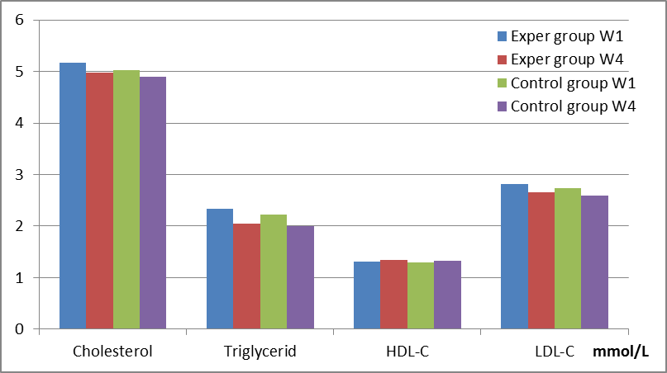
Chart 3.2. Blood lipid index changing before and after treatment
Table 3.42. Urine test results before and after treatment.
Index | Experimental group  (n=80) |  |  |  | Control group  (n=40) |  |  |  | p
Index | Week 1 (1) |  | Week 4 (2) |  | Week 1 (1') |  | Week 4 (2') |  | p
Index | n | % | n | % | n | % | n | % | p
Glucose | 16 | 20,0 | 0 | 0 | 9 | 22,5 | 0 | 0 | -
Protein | 6 | 7,5 | 0 | 0 | 2 | 5,0 | 0 | 0 | -
Ery | 5 | 6,3 | 0 | 0 | 2 | 5,0 | 0 | 0 | -
Leu | 3 | 3,8 | 0 | 0 | 2 | 5,0 | 0 | 0 | -

Reviews: Before the treatment, 25 patients were tested with urine glucose, 8 patients with proteinuria, 7 patients with hematuria, and 5 patients with urinary leukocytes. After the treatment, all patient urine test results returned to normal.

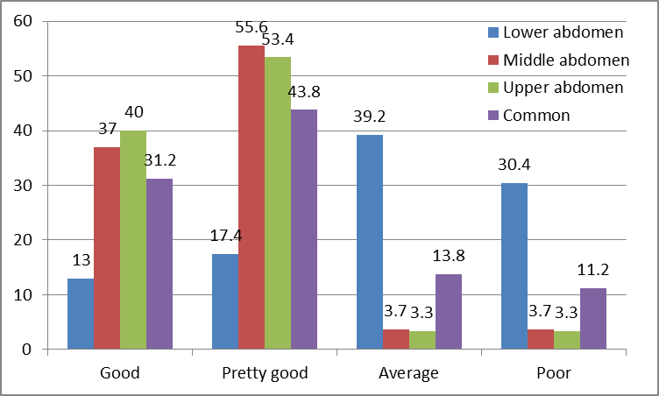

Chart 3.3. Results Assessment according to traditional treatment

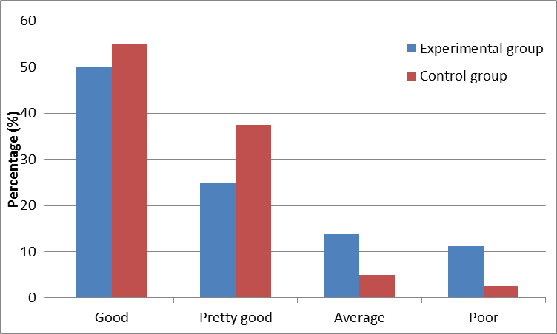

Chart 3.4. General treatment results

CHAPTER 4: DISCUSSION

Type 2 diabetes is a burden to society, is growing rapidly with high cost for many developing countries. Type 2 diabetes causes and pathogens are unclear, still, the scientific advance of modern medicine has still contributed to early diagnosis and treatment. If patients have good strategies in using medication, having healthy diet and doing exercises they will reduce risk and delay the appearance of disease complications.
Traditional medicine does not have a name for diabetes, but its manifestations belong to “thirst consumptive” disease. The basic of consumptive thirst, yin deficiency – heat dryness, directly affect lungs, spleen, stomach and kidney. Therapies commonly used are clearing heat lungs, nourishing yin and clearing lungs, nourishing yin and kidney, promoting production of body fluid and quenching thirst.
HT” medication formulas was built under traditional treatment based on differentiation of symptom complex of thirst consumptive disease “with 5 herbs nourishing yin, promoting body fluid production, quenching thirst (Radix Ophiopogonis and Radix Puerarae) in combination with Ginseng, Fructus Schisandrae and Pericarpium Citri Deliciosae having effects of reinforcing qi, invigorating spleen, and eliminating sputum. The medication focuses on treating the root of thirst consumptive disease.
The medication is powdered under a strict procedure and under the standard of Vietnam Pharmacopoeia IV.
4.1. TOXICITY STUDY AND EVALUATION OF HYPOLICEMIC EFFECTS OF HT IN EXPERIMENTAL ANIMALS
4.1.1. Toxicity study
4.1.1.1. Acute toxicity study
The maximum dose for mice was 50,0g/kg (compared to HED, higher than 12 times HED) (Table 3.1). This result is consistent with the medication composition, ingredients in the HT formulas were declared not to be toxic in the literature and in practice. The study showed that the medication is safe to use.
4.1.1.2. Sub-chronic toxicity study
Progression of type 2 diabetes is chronic, HT medication, must be used in a long time. The sub-chronic toxicity study was, conducted in 4 weeks at doses of 1,2g/kg/day and 3,6g/kg/day.
The study results showed that: The general condition and body weight change affected the hematopoietic system, liver and kidney function; the difference on the effect on kidney was not significant in comparison with control group. Macroscopic morphology of rabbit liver and kidney after using medication was not different from control group. The results of sub-chronic toxicity study was relevant to its safe and popular ingredients, so HT is suitable for long use in type 2 diabetes treatment.
4.1.2. Study on effects of hypoglycemic and hyperlipidemia adjustment.
Type 2 diabetes is a metabolic disorder characterized by hyperglycaemia, dyslipidemia is the cause and consequence of the disease at the same time. Experimental model plays a very important role in finding an effective herb or a formulas to treat type 2 diabetes.
In the world there are a lot of studies using rats with type 2 diabetes as research subjects under different methods. Causing diabetes by fat-rich diet combined with low dose STZ injection is a popular method in Vietnam.
Studies around the world often use STZ dose: 25-60mg/kg. In this study, we used dose of 30mg/kg. The results caused hyperglycaemia in white rats ≥ 11mmol / l, suitable for studying the effects of traditional medicine.
In this research, we have demonstrated that hypoglycemic effect of HT medication at HED reduced 28%, lower than Amary group (32,6%), but the difference was not statistically significant. Hypoglycaemia rates of 2 drugs on white rats caused type 2 diabetes is a success.
Histological results also showed that damage on pancreatic islet on HT groups was lower than Amaryl and oral saline groups.
HT formulas was the combination of 5 ingredients sharing the hypoglycemic effect through different components: saponins, triterpene, ginsenosid in ginseng and puerarin, saponosit in Radix Puerariae Thomsonii are proven to have hypoglycemic effect through several mechanisms such as stimulating β cells to secrete insulin, inhibiting glucose absorption in intestine; polysaccharide in Radix Ophiopogonis japonica reduces resistance, increases sensitivity inulin. Flavonoids in Pericarpium Citri reticulatae sitosterol in Radix Ophiopogonis japonici, schisandra in Fructus Schisandrae lowers glucose by promoting insulin through enhancing phosphorylation of this hormone. There are also other active ingredients having hypoglycemic effects according to different mechanisms which have been studied and proven.
4.2. RESULT ON TYPE 2 DIABETES TREATMENT OF HT
Research results on experimental animals were reported and allowed to use on volunteer patients with type 2 diabetes at Military Institute of Traditional medicine. The medication was evaluated the therapeutic effect on type mild and moderate 2 diabetes patients through clinical symptoms and sub-clinical indicators. Therapeutic effect on patients with type 2 diabetes has been evaluated based on standards of modern and traditional medicine. The process of the study was conducted under the current regulations of the Ministry of Health of Vietnam on traditional medicine study.
HT formulas was built on the basis of traditional treatment based on differentiation of symptom complex of thirst consumptive disease, so action mechanism has not been determined, the research methods used are: Research - clinical trial – comparison between before and after treatment and comparison traditional medicine to western medicine.
In addition to use modern medicine to prove the medication application in clinic, the study also our desire to contribute to elucidate traditional medicine principles and gradually modernize the traditional medicine. Therefore, the study subjects were selected on the basis of type 2 diabetes patients of modern medicine, but they must meet traditional medicine diagnostic criteria of thirst consumptive diseases and were divided into 3 kinds (upper, middle and lower abdomen). The study results were assessed according to modern and traditional medicine. Control groups were used in the study and 3 types of thirst consumptive diseases were compared.
4.2.1. Patients characteristics
4.2.1.1. Age and sex distribution
- Age and sex distribution: 120 studied patients, the youngest is 40 and the oldest is 74. The highest age range rate is 60-69 (38,3%), then 50-59 (26,7%), 23 patients ≥ 70 (19,2%), 19 patients in 40-49 (15,8%), no patients under 40. The difference between the two groups and between 3 kinds of thirst consumptive diseases was not statistically significant (p> 0,05).
Our findings were suitable with others: Mai The Trach (1982) found that the age group 55-60 accounted for the highest rate (48,3%). Le Van Bach, Tran Huu Dang (1993) studied on 72 patients with type 2 diabetes found that the lowest age was 40 and the oldest was 79. According to Bui Thi Hong Thuy (1998) who studied on 60 patients with type 2 diabetes: the lowest age was 42 and the oldest was 79; 40-59 age group accounted for the highest rate (66,66%).
- Gender distribution: In the study, there were 78 male patients, accounting for 65%, 42 female patients, accounting for 35%, statistically significant (p <0,001). Military Institute of Traditional Medicine mainly treat patients in army forces both working and retiring where men count much more than women. That is the reason for such patient difference.
4.2.2. Therapeutic effects
The clinical symptoms (feeling thirsty, feeling hungry, urinating often, blurry vision, headache, fatigue, lack of sleep, numbness, sweating and constipation) started to change from 2nd week and were significantly improved at 3rd week and returned to normal after 4 weeks of treatment (table 3,33). After 4 weeks of treatment, experimental groups achieved better results than the control group with statistical significance (Table 3,34).
According to traditional medicine, thirst consumptive disease is due to bad eating habits with high-fat food, alcohol causing heat in middle abdomen or due to seven emotions causing depression which leads to heat; or due to insufficient innateness, excessive sex leading to loss of essence, prolonged disease leads to lung dysfunction, and specially kidney dysfunction. Lungs regulate body fluid, if this function is in trouble, it leads to often urinating. The lungs fail to distribute body fluid leading to dry mouth and feeling thirsty. Heat stomach leads to much eating and feeling hungry. Failure kidney without arresting discharge leads to cloudy and sweet urinating.
Ingredients in HT formulas have the effects of nourishing yin, clearing heat, promoting body fluid production, they are also proven to deal with feeling thirst, often drinking, constipation, common symptoms of type 2 diabetes.
Radix Puerariae Thomsonii has the effect of regulating the muscular tonus, clearing heat and expelling miasma reducing symptoms as headache, blurry vision and numbness; Radix ginseng, Radix Ophiopogonis japonica, Fructus Schisandrae, and Pericarpium Citri reticulatae have effect of tonifying liver and kidney, nourishing yin and invigorating spleen, they are herbs to treat the root disease (deficiency of energy and yin).
Therapeutic effects of traditional medicine treatment
Therapeutic effects in upper and middle abdomen are better than lower abdomen, the difference was statistically significant, and the number of patients achieving poor results in 80 patients with type 2 diabetes treated by HT medication was 7/9. Our clinical study results in comparison with Tieu Ngoc Chien (2013) who evaluated the effects of “Thap vi giang duong” formulas on 120 mild tyoe 2 diabetes:
- Lower abdomen: good: 15,8%; pretty good: 36,8%; average: 7,7%; poor: 39,5%
- Middle abdomen: good: 75%; pretty good 25%; Average: 0%; Poor: 0%
- Upper abdomen: good: 61,9%; pretty good: 38,1%; Average: 0%; Poor: 0%
The research results of Duong Dang Hien (2005), studying the effects of "Dong Do Diabetes" in the treatment of type 2 diabetes without complications, after 30 days of treatment: good and fair results in upper abdomen: 80%, middle abdomen: 75% and 61% in lower abdomen; poor results in upper abdomen: 0%, middle abdomen: 8,3%, and 4,8% in lower abdomen.
In conclusion, research results of different authors showed that, upper and middle abdomen achieved better results than lower abdomen. Poor treatment efficiency is mainly in lower.
Traditional medicine believes the nature of thirst consumptive disease is yin deficiency leads to internal heat syndrome, although the disease is divided into 3 types upper, middle, lower abdomen, it is still one kind of yin deficiency and still affects kidney. The book “Collection of Differential Diagnosis and Treatment” (Lei Zheng Zhi Cai) said: "upper abdomen: mild, middle abdomen: severe, lower abdomen: danger” so "lower abdomen is the result of the disease severity in middle, upper abdomen, and damage in kidney due to heat in lungs and stomach”. The effective thirst consumptive disease therapy is treating its: kidney. When the disease affects renal function it is usually at a later stage and limits the therapeutic effect of the treating therapy. This suggests the long-term use of HT medication in lower abdomen and the addition of ingredients notifying kidney.
The general results after treatment
Table 3.45 showed the results after 4 weeks of treatment: good: 50%, pretty good: 25%, average: 13,8%, poor: 11,3%. Control group: good: 55%, pretty good: 37,5%, average: 5%, poor: 2,5%.
Therapeutic effect of type 2 diabetes treatment in comparison with other studies on traditional medicine: Nguyen Huu Chung (2004), Research on hypoglycemic effects of Ilex kaushue on patients with mild and moderate type 2 diabetes after 30 days of treatment: good: 71%, pretty good: 21,1%, poor: 7.9%; Duong Dang Hien (2005), study on the effects "Dong Do Diabetes” in the treatment of type 2 diabetes without complications, after 30 days of treatment: good and pretty good: 70,9%, average: 23,6%, poor: 5.5%; Tieu Ngoc Chien (2008), evaluating the effect of GALUCRON in type 2 diabetes treatment, after 60 days of treatment: the drug had hypoglycemic effect and well controled HbA1 in 85,72% patients with mild and moderate diabetes type 2.
Table 3.45 showed that the general treatment result on HT groups was lower than the control groups, although the difference was not statistically significant. As the control group was treated by Amaryl, a type 2 diabetes drug of 2nd generation of sulfonylurea group stimulating pancreatic insulin secretion. Table 3.37: the fasting blood glucose reduced 26.8% in Amary group, while HT group decreased 25.2%, according to the evaluation criteria, the fasting blood glucose is an important criteria in evaluating the results of type 2 diabetes treatment.
4.3. UNDESIRED EFFECTS OF HT
HT was processed by the Faculty of Pharmacy of Military Institute of Traditional Medicine under the Vietnam Pharmacopoeia IV. The medication was tested the acute toxicity LD50 in Faculty of Experimental Study, scientific empirical study of Military Institute of Traditional Medicine and was tested the sub-chronic toxicity at Department of Pharmacology - Hanoi University of Medicine.
In clinic, in 80 patients treated by HT, 3 suffered from abdominal pain and 2 digestive disorders: loose stool. These symptoms disappeared after 1 or 2 days. In control group, 2 patients suffered abdominal pain, 1 digestive disorders, and these symptoms disappeared without treatment.
In addition, no undesirable effects such as nausea, vomiting, headache, rash, urticaria, etc appeared.
Functional kidney and liver test results and haematological data before and after treatment unchanged, not statistically significant (p>0.05)

CONCLUSION

1. The oral HT medication is highly safe, has hypoglycemic effects and adjusts the hyperlipidemia in experiment:
- Lethal dose 50% (LD50) has not been determined on mice under Litchfield - Wilcoxon. The dose o 50g/kg (the highest dose for mice) did not kill the mice.
- HT at dose of 1,2g/kg/day and 3,6g/kg/day in 4 weeks caused no changes in hematological indicators, blood biochemistry and histology of liver and kidney of rabbits.
- On the animal model caused type 2 diabetes by high-fat diet and STZ dose 30 mg/kg: HT reduced blood glucose at the dose of 2,8g/kg/day (HED) decreased 28% at dose of 8,4g/kg/day (3 times HED) decreased 20,3% during 10 days of treatment.
- HT tended to lower cholesterol, LDL-C, triglycerides increased HDL-C (no statistically significant difference in comparision with before treatment).
2. The oral HT medication is highly safe, has hypoglycemic effects and adjusts the hyperlipidemia in type 2 diabetes patients
HT started to lower blood glucose at the 2nd week. After 4 weeks of treatment the blood glucose significantly reduced (p<0,001). The fasting blood glucose in HT group (26,80%) reduced less than the Amaryl group (19,54%). Blood glucose in upper and middle abdomen decreased more than the lower abdomen (statistically significant, p<0,05).
The medication reduced Cholesterol, LDL-c, Triglycerid and increased HDL-c on patients, but the difference was not statistically significant (p>0.05).

SUGGESTIONS

- HT medication should be more studied, evaluated the hypoglycemic effect in clinic on mild and moderate type 2 diabetes treatment in longer time. It should be used as the supporter in severe type 2 diabetes treatment.
- It is practical to find a more suitable easy-to-use and easy-to-store form of the medication. The medication should be provided for outpatients.

LISTS OF AUTHOR’S STUDIES
1. Lê Hồng Tuyến, Nguyễn Minh Hà, Nguyễn Văn Cường (2014) « A trial on chronic toxicity and effects of HT on general conditionl and hematological indicators of experimental animals », Journal of military traditional medicine and pharmacy, Vol 4,Nº2, Military Institute of Traditional Medicine, P22-28.
2. Lê Hồng Tuyến, Nguyễn Minh Hà (2014), "An experimental study on the effects of HT on liver and kidney function and morphology », Journal of military traditional medicine and pharmacy, Vol 4, Nº3, Military Institute of Traditional Medicine, P 23 - 29.
- Lê Hồng Tuyến, Nguyễn Minh Hà, (2016), "A study on therapeutic effects of HT on patients with type 2 diabetes in Military Institute of Traditional medicine", Journal of military traditional medicine and pharmacy, Vol 6, Nº1, Military Institute of Traditional Medicine.

