**INTRODUCTION OF THESIS**

**1. BACKGROUND**

Undescended testis (UDT) or cryptorchidism, is the most congenital defect in male children. In the literature, the incidence of UDT is 3-5% in the fullterm neonates and 17- 36% in the preterm babies. In the first 3 months, because of the high surge of male sexual hormone, testis spontaneously descends in up to 70-75% of infants, so after 6 months the incidence of UDT is approximately 0,8- 1,8%. If the UDT is untreated, it may be the risks of malignancy, subfertility, infertility, and psychological influences for patients.

Diagnosis and follow-up of UDT do not require advanced techniques, mainly depend on clinical examinations. Infants with UDT should be treated early at 1-2 years old, since if the treatment is delayed, it may cause unrecovered testis damages. There are two main treatment methods for UDT, hormonal therapy and orchidopexy. Hormonal therapy in UDT has been used in Vietnam and many other countries. It is reported that, this method brings success for 10-65% of UDT cases. Orchidopexy plays an important role in testis relocation. It is noted that the success rate achieved in 70-95% of UDT cases with orchidopexy, and post-operative complications have seen in 2% of UDT cases.

To date, in Vietnam, the numbers of UDT infants treated before 2 ages were limited, just under 10%. At the pediatric hospitals with the pediatric and surgical specialists, the median age of UDT cases treated with orchiopexy was at 5,8-13,5 years. The considerable numbers of UDT patients were treated at post-puberty or detected by infertility examination. In Vietnam, there is not any systematic studies to diagnose UDT after birth, to determine the incidence of UDT in neonates, to follow-up the progression of UDT patients in the first year and to estimate suitable time to start hormonal therapy and/or orchiopexy, to research treatment challenges, and to assess the results of early treatment. Therefore, we carried out the project “**Early diagnosis and assessment of the treatment results of undescended testis”** with three objectives:

*1. To early diagnosis and determine the incidence of**undescended testis.*

*2. To describe the progression of undescended testis in the first year.*

*3. To assess the results of hormonal therapy and/or orchiopexy for patients with undescended testis.*

**2. THE URGENCY OF THE PROJECT**

Undescended testis is the most congenital defect in neonatal males. The rate of UDT in male children over 1 year old is 0,8-1,8%. Untreated or lately treated UDT may be a risk factor of infertility, testicular malignancy, damaged testicles and psychological trauma. Early diagnosis and treatment of UDT before children reach to 2 years by hormonal therapy and/or orchidopexy is essential to prevent long term consequences.

There are advanced techniques to diagnose UDT, which mainly based on clinical examinations. In Vietnam, over 70% of cryptorchidism cases were detected by their family, and the children with UDT were lately hospitalized. Only 10 % of UDT patients were treated before 2 years old. A number of cases were admitted with serious complications such as: infertility, testicular cancer because of late treatment or un-treatment. Therefore, a systematic project should be carried out to study on early diagnosis, assessment of incidence of UDT after birth, follow-up of UDT progression in the children in the first year. Further more, studies on children with UDT including etiology, pathophysiology, optimal time for treatment, assessment of the results of early treatment by hormonal therapy and/or orchiopexy before 2 years, should be conducted.

**3. THE CONTRIBUTIONS OF THE THESIS**

**This thesis contributes to:**

- Apply the early diagnosis for male neonates with UDT at medical centers of obstetrics and pediatrics and children vaccination units.

- Follow up the natural progression of UDT after birth to report the time and position of testicular descent, which then contribute to decide the optimal time for indication of hormonal and surgical therapy.

- Educate the obstetric and pediatric staff to early identify UDT, which is helpful for community health care. This increases the quality of life and reproductive health as well.

**4. RESEARCH CONTENT:**

The thesis contains 124 pages: two pages of the background; 38 pages of the chapter 1 (Overview); 15 pages of the chapter 2 (Subjects and research methods); 27 pages of the chapter 3 (Research results); 38 pages of the chapter 4 (Discussion); two pages of the conclusion and two pages of the recommendation.

There are 42 tables, 11 charts, two pictures, two outlines, and 137 references (including 18 references in Vietnamese and 119 in English).

**CHAPTER 1**

**OVERVIEW**

Definition: Undescended testis or cryptorchidism, the most common congenital defect in males, is defined as the absence of normal testicular tissue at the base of scrotum, which is caused by the abnormal stop of one or both testes in its migration to the scrotum.

**1.1. Diagnosis of UDT**

It is reported that the age of early diagnosis has been decreasing by time. Some researchers, Donald S in 1954 and Baley & Nelson in1959, recommended that children with UDT should be diagnosed and treated before 6 years of age. Hadziselimovic et al in1983 pointed that there were the histological changes of testes within UDT cases identified at two years of age; he then recommended that children with UDT need to be diagnosed and treated before 2 years old. In 2006, John H followed up the migration of testes and reported that testes would no longer descend after 6 months, and he suggested that the time to early diagnose and treat was from 6 to 15 months of age. Up to date, it has been reported that early diagnosis and treatment even should be taken an account at birth.

**Clinical examination**: In the warm room, the child should be kept in the position of supine with frog legs. Scrotum will look small and/or flat in one side, in both side with bilateral cryptochidism. One hand palpates from abdomen down to the inguinal direction, another hand palpates from scrotum up to the inguinal area. The testis will be found under the hand with elliptic shape, well-shaved, solid, easy to be moved up and down in the inguinal path. During examination, doctors can find out added anomalies, testicular tumor, or congenital defects such as inguinal hernias, hypospadias, penis subsidence, or sexual ambiguous.

**Imaging investigation**

Ultrasound supports to define the position, measurement, and quality of the testis. This technique should be performed when the child is 3- 6 months to the aims of follow-up and treatment. The computed tomography (CT) scanner and magnetic resonance imaging (MRI) are indicated in cases of non-palpable or unidentified cryptorchidism by ultrasound. Endoscopy is a helpful method to diagnose and treat for non-palpable cryptorchidism. It brings the believable results, and may consider as the golden standard for diagnosis of non-palpable cryptorchidism.

**1.2. Natural progression of cryptorchidism**

After 6 months of birth, the surge of FSH and LH concentration stimulates the testes to increase testosterone secretion called mini-puberty. At this period, testes spontaneously descend into the scrotum in 70% of cases. The incidence of UDT found ranges from 2-8% after birth and 0.8-1.8% at 3-12 months of age. The UDT spontaneously descend into the scrotum less than 5% after 6 months of age.

Untreated cryptorchidism may lead to reduce numbers of germ cells, to delay the mature or form anomalies of germ cells, to decrease numbers of Leydig cells, to reduce the formation of spermatogenium tubes, to form immature Sertoli cells and deposit calcium… These clearly appear in a children after 2 years old, and cause infertility in when they are adults. In 2013, Thanh N.H et al studied 144 patients over 18 years of age with bilateral cryptorchidism. He showed that 100% of cases was no spermatogonia. 49.1% of the patients with unilateral cryptorchidism had normal sperm density. The patients with cryptorchidism treated after puberty were degenerated atrophy, fibrosis, reduced spermatogenesis that did not depend on the high or low position of testes. Additionally, the authors found the risk of carcinoma in UDT patients underwent orchidopexy before 13 years was higher than in the normal people 2.23 times. Inversely, the patients operated after 13 years had higher risk of testicular cancer than normal 5.4 times and lately suffered from psychological trauma.

**1.3. The treatment of cryptorchidism**

***1.3.1. Hormonal treatment***

It is confirmed that sex hormones have important roles in promoting descent of cryptorchidism. This hormonal choice is based on the pathogenesis mechanisms since it is a non-invasive method, creates favorable conditions for the surgery due to lower descended testes, and slows down the degenerative process of cryptorchidism.  The high dose of gonadotropin and testosterone is essential for the transformation of the spermatogonia and the low-dose of hormonal therapy is helpful for fertility.

**\* Indication:** all male children have cryptorchidism after age 1. Currently, the authors’s recommendation of the use of low doses for children <2 years of age is 250-300 unit HCG/time, 2-3 times/week, 7-10 times/1stage. The treatment may be repeated after round 1 from 2-3 months if the testes haven not descended into the scrotum. Side effects of the drug were rare and transient.

**\* Contraindications**: happened in: 1) infants with UDT under six months because at that time, the testes still continue descending to the scrotum, and the male sex hormonal concentration is still high. Cryptorchidism with inguinal hernia or hydrocell need to operate early to treat both diseases at the same time; 2) ectopic testis; 3)cryptorchidism accompanied by abdominal pressure reduction as the Prune-Belly syndrome.

***1.3.2. Surgical treatment***

Surgery therapy (or orchiopexy) is applied if testicles have not descended into the scrotum after treatment with hormones or patients are at older age (puberty) to treat by hormones

After the testes stop moving down to the scrotum in first year and prior to the degeneration of the testes from the second year, the age of surgery for UDT is best from 12-18 months. The European consensus, 2008, recommended that surgery in ages 6-12 months possibly improves the function of spermatogenesis and reduces the rate of malignancy. The rate of orchiopexy complications is low, under 2%.

At 3 years of age, the testicular volume in children with cryptorchidism who were successfully operated at 9 months old, developed considerably bigger, and reached normal volume in some patients compared to the patients with late orchiopexy. The male fertility in the bilateral cryptorchidism patients is lower than that in normal children and unilateral cryptorchidism cases. The fertility rate in men who successfully underwent orchiopexy and unilateral cryptorchidism patients or testectomy in one side is about 5% lower than normal men.

**Chapter 2**

**SUBJECTS AND RESEARCH METHODS**

**2.1. Research subjects**

- The male children who were born at the National Hospital for Obstetrics and Gynecology in the period from 1st November, 2009 to 30th June, 2012, were clinically examined to early detect undescended testes one or both sides in the scrotum.

- Criteria for selecting subjects:

+ All male children with the male external phenotype

+ Clinical consultations over twice defined that the testis in the scrotum, 1 or 2 sides were not found by the migration stop on the way to the scrotum.

- The exclusion cases:

+ Ectopic testicles, retractile testicles, ambiguous gender, pituitary insufficiency, malformations such as Prader Willi, Labhart, Klinefelter ...

+ Patients who were died by other diseases, did not visit by appointment, their parents refused to participate in the research or follow up and treatment. Patients who were treated in other medical facilities were rejected from the research.

**2.2. Methodology**

***2.2.1. Research design***

- Objective 1 and Objective 2: We conducted a descriptive prospective research methodology. The sample size is calculated by the formula:



+ For premature infants, p = 25%, error E = 5%; n = 289, rounding n = 300

+ For full term infants: p = 3%, E = 0.5%, n = 6987, rounding n = 7000

- Objective 3: research method is nonrandomized clinical trial. This aimed to assess the effectiveness of hormonal therapy and orchiopexy.

Sample size calculation formula for this treatment intervention research is:

$$n=\frac{{\left[z_{1-α/2}\sqrt{2PQ}+z_{1-β}\sqrt{P_{1}\left(1-P_{1}\right)+P_{2}\left(1-P_{2}\right)}\right]}^{2}}{{(P_{1}-P_{2})}^{2}}$$

P1: the rate of cryptorchidism untreated with hormones; P1 = 95%.

P2: the rate of cryptorchidism after hormonal therapy; P2 = 80%.

We calculate the theoretical sample size, n = 75 .

***2.2.2. Data collection methods***

Medical records in tracking form including: clinical examination, accompanied malformations, family history, medical reports from the first year following-up, the ultrasound measurement of testicular size in three dimensions: length, width, height, V(ml) = 0.71 x length x width x height/1000.

Hormonal therapy: Children ≤ 2 years who were intramuscularly injected 300 units of HCG/ 1 injection, 2 days interval between each injection, and a total of 7 doses. If testes completely descended, the hormonal treatment would be stopped. If the testes did not or partly descended, patients would be repeatedly injected the second stage after the first phase 2-3 months.

Surgical therapy: in cases of: 1) children with congenital inguinal hernia, orchiopexy would be done together with hernia operation; 2)cryptorchidism after having completed 2 stages of 3 months hormonal therapy; 3)cryptorchidism with stage 1 completion of hormonal therapy but the immediately surgery request from their family, or family denial of stage 2 hormonal treatment; 4) the child's parents refused treatment by hormone and expected to have orchiopexy.

**2.3. Data processing**

Data analysis using the software SPSS statistics 17.0, and statistical algorithms in medicine EPI-INFO 6.04.

**Chapter 3**

**RESEARCH RESULTS**

**3.1. General characteristics of the objective**

The total number of male infants examined to detect UDT were 9918; premature infants were 1046; fullterm infants were 8872; children with UDT were 473 neonates and 707 children with UDT.

+ The number of children excluded from the research in the first year were 105

**3.2. Results of early diagnosis, incidence of cryptorchidism**

The incidence of cryptorchidism was 25.1% (263/1046) in preterm infants and 2.4% in fullterm babies (210/8872). The UDT rate in cases with birth weight under 2500g was 26.1% (284/1085 cases), higher than the rate of cryptorchidism in infants weighing ≥ 2500g ((2.1%)189/8833, p < 0.01). The incidence of general cryptorchidism was 4.8% (473/9918), of bilateral cryptorchidism was 49.4%, and unilateral cryptorchidism was 50.6%; right undescended testis accounted for 28.8% and left one was 21.8%.

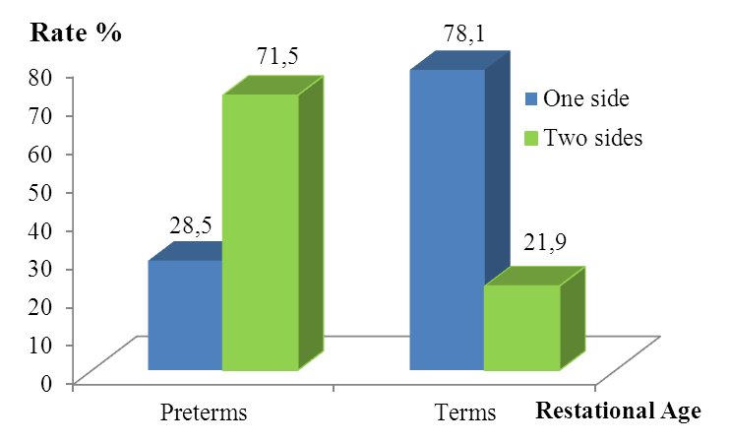

***Chart 3.1: Rate of children with cryptorchidism by side and gestational age***

***Comment:*** Fulltterm infants mainly got cryptorchidism in one side (78.1%) but preterm babies mainly have UDT in two sides (71.5%).

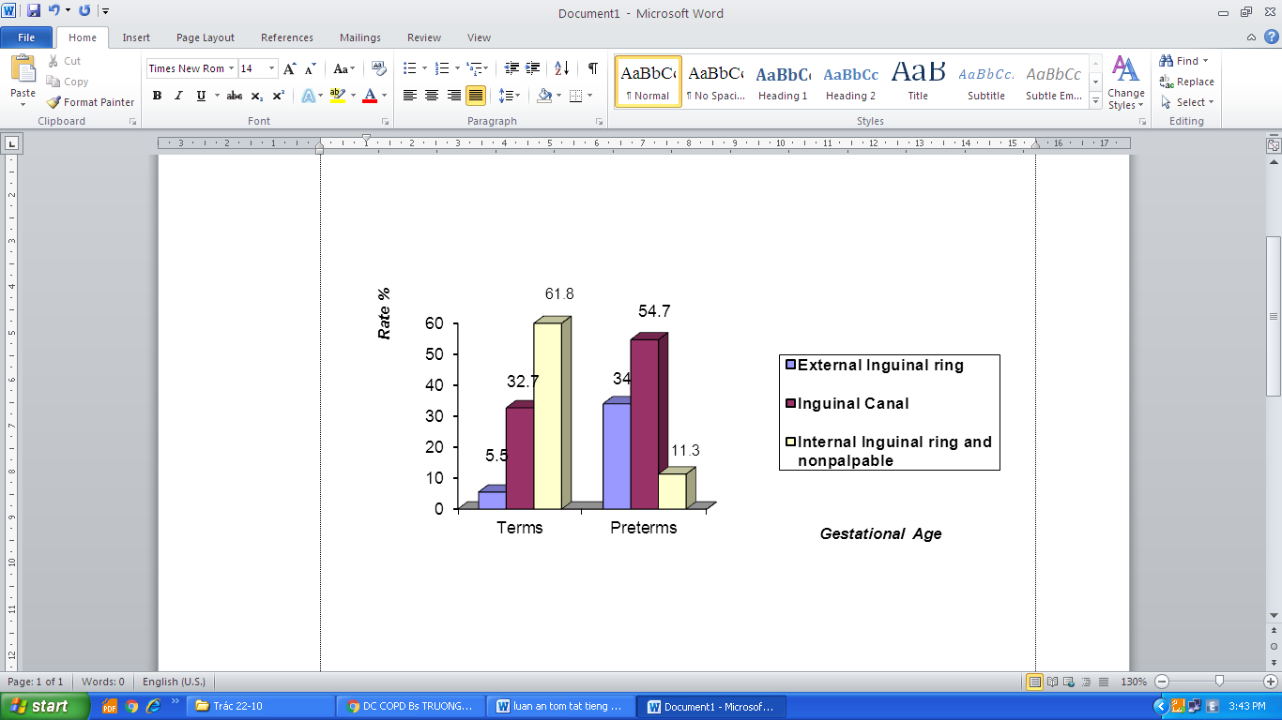

***Chart 3.3: Positional rate of cryptorchidism by gestational age***

***Comment***: Cryptorchidism position in preterm infants was mainly in the inguinal canal and external inguinal ring (88.7%). Cryptorchidism locus in full-term infants was mainly in the internal inguinal ring and non-palpable cryptorchidism was in 61.8%, only 5.5% of cryptorchidism cases were in external inguinal ring.

***Table 3.7: Additional defects after birth***

|  |  |  |  |
| --- | --- | --- | --- |
| Group | Malformation | n | Rate (%) |
| Relate to the external genital | Hydrocell | 62 | 13.1 |
| Inguinal hernia | 16 | 3.4 |
| Hypospadias | 9 | 1.9 |
| Total | 87 | 18.4 |
| Whole body | Hydrocephalus | 1 | 0.2 |
| Congenital heart | 9 | 1.9 |
| Down syndrome | 8 | 1.7 |
| Others | 16 | 3.4 |
| Total | | 121/473 | 25.6 |

***Comment***: 18.4% of children with cryptorchidism had malformations relating to external genitals. The most common malformation was hydrocell, accounted for 13.1%.

**3.3. Natural migration of cryptorchidism in the first year**

105 children were excluded from our study because of mortality (21 boys), and not back for re-examination (84 boys). Numbers of children followed up in the first year were 368 infants with 530 UDTs.

***3.3.1. The incidence of cryptorchidism by time***

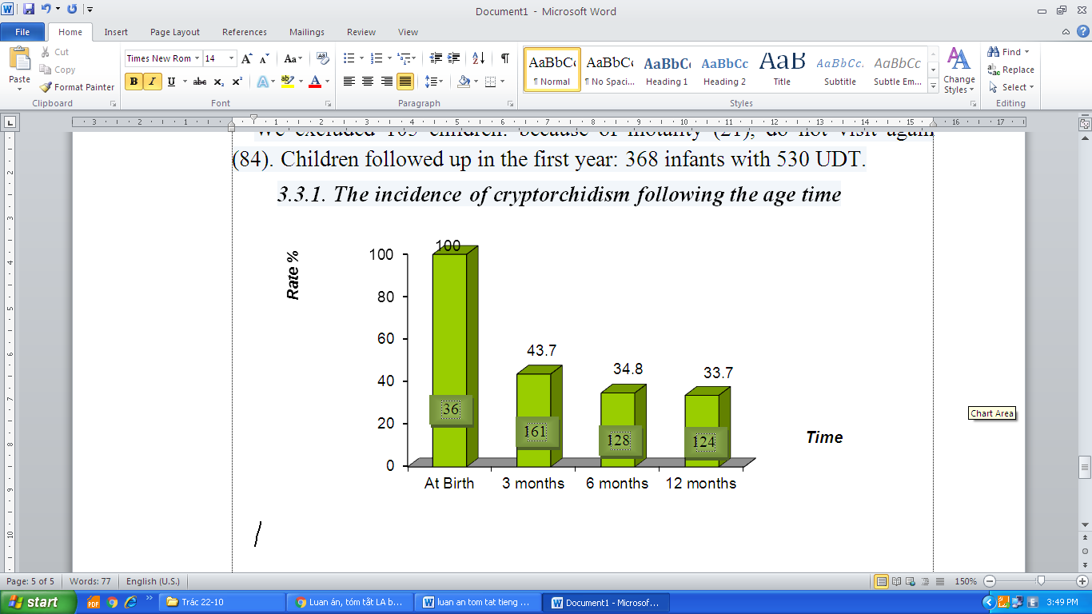

8

***Chart 3.4: Numbers of children with cryptorchidism by time***

***Comment:*** After 3 months, the number of children with cryptorchidism rapidly decreased from 368 to 161 infants, and to 128 infants after 6 months. From 6 to 12 months, there were 4 children having testes descent into the scrotum. The general rate of cryptorchidism after birth was 4.8%; reduced to 1.6% after 3 months and 1.3% after 6-12 months.

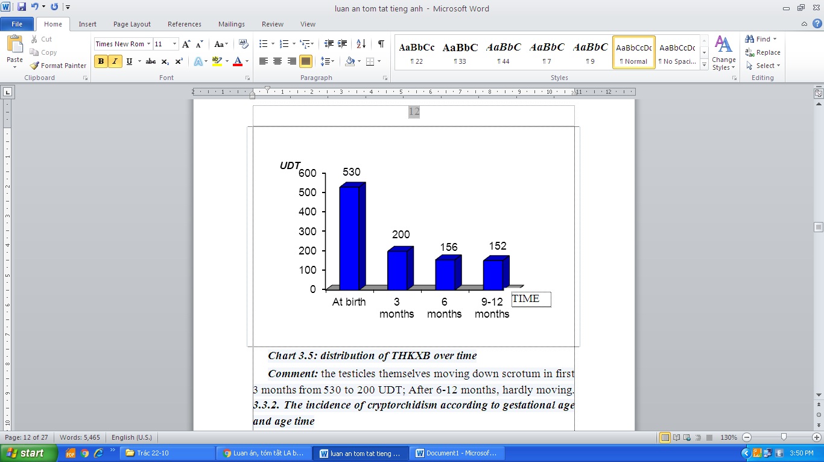

***Chart 3.5: Distribution of cryptorchidism over time***

**Comment**: In 530 UDTs, 200 cases had the testes spontaneously moving down to the scrotum in the first 3 months. After 6-12 months, testes nearly stayed their original positions.

***3.3.2. The incidence of cryptorchidism by gestational age and time***

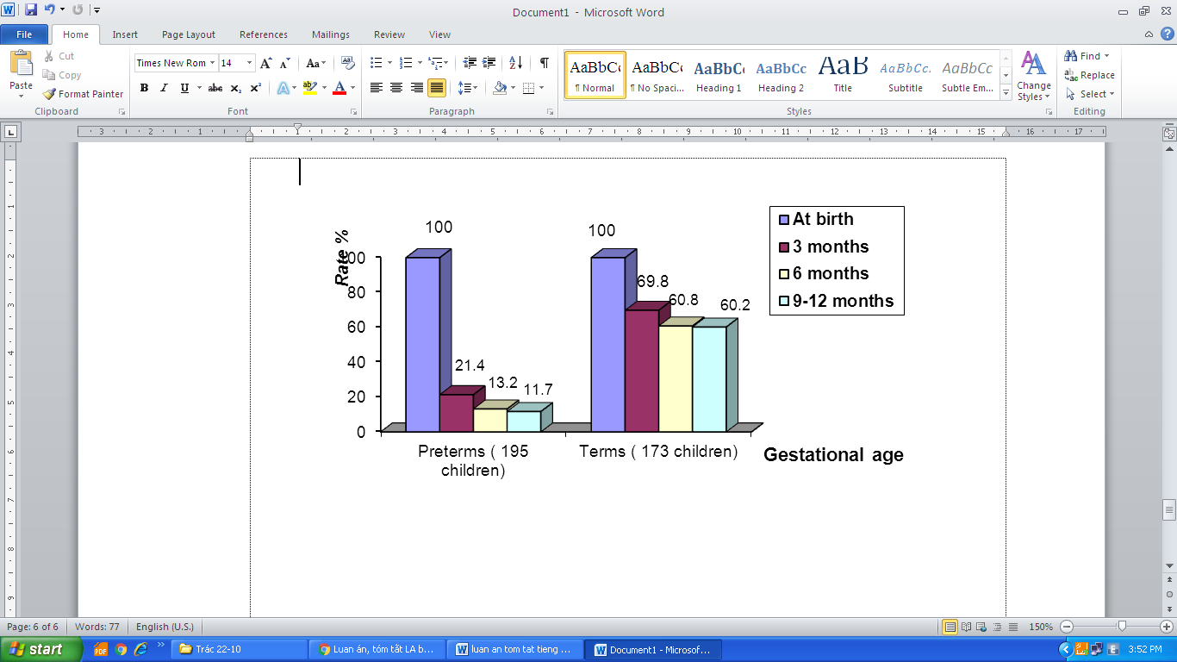

Figure 3.7: The progress of children’s cryptorchidism following gestational age

Comment: In the first year, testes of preterm infants with cryptorchidism spontaneously descended into the scrotum in 88.3% of cases while this rate was 39.8% in fullterm infants.  
3.3.3. The progress of migration of testes in cryptorchidism patients by their location after birth.

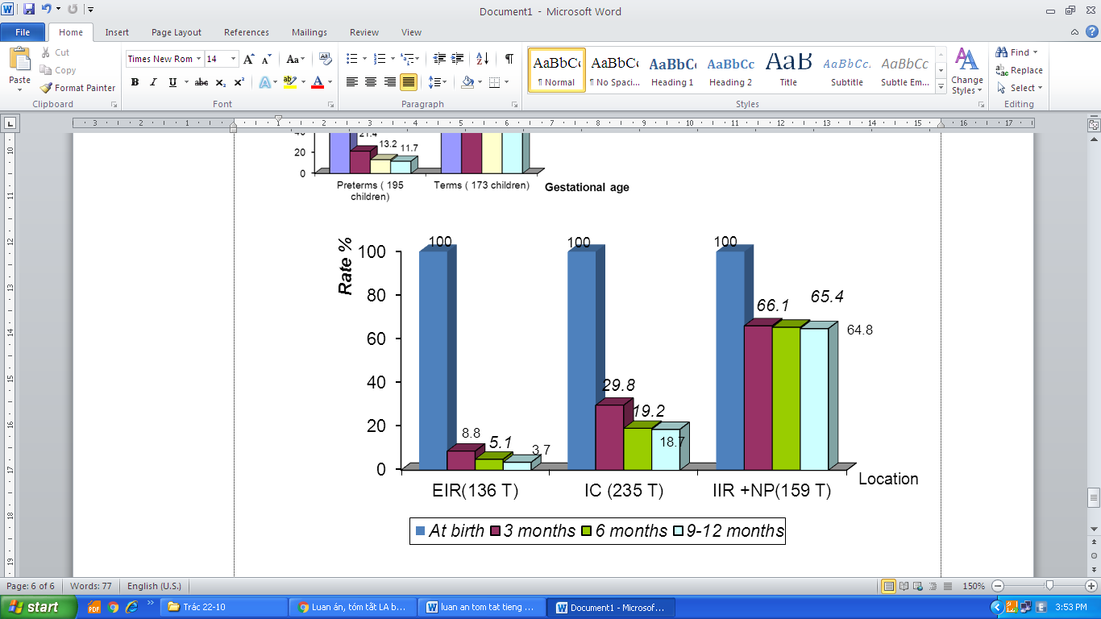

Chart 3.8: the rate of cryptorchidism existence by their original position in the first year

EIR= External inguinal ring, IC= Inguinal canal, IIR +NP= Internal inguinal ring and non-palpable, T= Testis

Comment: testes in all original positions spontaneously descended into the scrotum in the first 3 months. The testes at the external inguinal ring spontaneously descended in 96.3% of cases.

Table 3.13: Spontaneous descent of cryptorchidism in the first year

|  |  |  |  |  |
| --- | --- | --- | --- | --- |
| Position | UDT at birth | Entirely descended | Partly descended | Undescended |
| External inguinal ring | 136 | 131 | 0 | 5 |
| Inguinal canal | 235 | 191 | 20 | 24 |
| Internal inguinal ring and non-palpable | 159 | 56 | 82 | 21 |
| Total | 530 (100%) | 378 (71.3%) | 102 (19.2%) | 50 (9.5%) |

***Comment:*** 71.3% of UDT, testes spontaneously descended into the scrotum during the first year, and partly descended in 19.2% of cases.

***3.3.4. The changes of the average testicular volume in the first year***

***Table 3.14: Comparison of the average testicular volume with normal testicles.***

|  |  |  |
| --- | --- | --- |
| **UDT position** | **Testis’s volume** | |
| **At 3 months of age** | **At 12 months of age** |
| Right side | 0.62 ±0.24 cm3 | 0.60±0.23 cm3 |
| Contralateral testis | 0.68 ±0.25 cm3 | 0.80 ±0.29 cm3 |
| p value | p = 0.71 | p < 0.05 |
| Left side | 0.58± 0.22 cm3 | 0.56±0.22 cm3 |
| Contralateral testis | 0.73± 0.24 cm3 | 0.77±0.26 cm3 |
| p< 0.05 | | |

***Comments:*** the average volumes of UDT were smaller than the average volumes of normal testes at 12 months of age, with statistical significant, p <0.05.

**3.4. Results of treatment**

A total of 124 children with cryptorchidism were treated after 1 year old including 99 cases with hormonal therapy; 5 cases with inguinal hernia with surgery therapy; 11 cases with orchiopexy without hormonal therapy, and 9 patients with treatment in other medical facilities.

***3.4.1. The results of hormonal therapy in UDT patients***

Ninety nine children with cryptorchidism were treated with hormonal therapy stage 1 in which only 15 children (15.2%) had testes descending into the scrotum.

**Table 3.21. The result of hormonal therapy stage 1 by testes’s location**

|  |  |  |  |  |
| --- | --- | --- | --- | --- |
| **Location** | **n** | Entirely descended | Partly descended | Undescended |
| External inguinal ring | 44 | 17 | 0 | 27 |
| Inguinal canal | 48 | 2 | 11 | 35 |
| Internal inguinal ring | 14 | 0 | 8 | 6 |
| Nonpalpable | 16 | 0 | 5 | 11 |
| **Total** | **122 (100%)** | **19 (15.6%)** | **24 (19.7)** | **79 (64.7%)** |

Comment: after hormonal therapy stage 1, 15.6% of cryptorchidism completely descended into the scrotum, and partly descended in 19.7% cases.

Notes: after hormonal therapy stage 1; 13 patients’s families immediately having orchiopexy requests. In 71 children with cryptorchidism participated in hormonal therapy stage 2, cryptorchidism descended into the scrotum in 15 children (21.1%) .

Table 3.26: Results of hormonal therapy stage 2 by testes’s location

|  |  |  |  |  |
| --- | --- | --- | --- | --- |
| **Location** | **n** | Entirely descended | Partly descended | Undescended |
| External inguinal ring | 33 | 17 | 0 | 16 |
| Inguinal canal | 38 | 1 | 10 | 27 |
| Internal inguinal ring | 9 | 0 | 3 | 6 |
| Nonpalpable | 9 | 0 | 2 | 7 |
| **Total** | **89 (100%)** | **18 (20.2%)** | **15 (16.9%)** | **56**  **(62.9%)** |

***Comment:*** after hormonal therapy stage 2, 20.2% of cryptorchidism completely descended into the scrotum and partly descended in 16.9% of cases.

***Table 3.27: results of two stages of hormonal therapy for patients with cryptorchidism***

|  |  |  |  |  |
| --- | --- | --- | --- | --- |
| **Location** | **n** | Entirely descended | Partly descended | Undescended |
| External inguinal ring | 44 | 32 (72.7%) | 0 | 12(27.3%) |
| Inguinal canal | 48 | 5 (10.4%) | 19 (39.6%) | 24(50.0%) |
| Internal inguinal ring | 14 | 0 | 9 (64.3%) | 5(35.7%) |
| Nonpalpable | 16 | 0 | 7 (43.7%) | 9(56.3%) |
| **Total** | **122** | **37 (30.3%)** | **35 (28.7%)** | **50(41%)** |

***Comment***: The success rate of cryptorchidism descended into the scrotum was 30.3%, partly descended was 28.7%. Testes located at the external inguinal ring completely descended into the scrotum in 72.7% of cases after 2 stages of hormonal therapy.

***Table 3.28: Results of two stages of hormonal therapy by clinical examination***

|  |  |  |  |
| --- | --- | --- | --- |
| **Clinical examination** | **Number of UDT with hormonal treatment** | **Respond** | **Nonrespond** |
| Palpable | 106 | 65 (61.3%) | 41 (38.7%) |
| Nonpalpable | 16 | 7 (43.7%) | 9 (56.3%) |
| Total | 122 | 72 (59.0%) | 50 (41%) |
| p = 0.1 | | | |

***Comment:*** Palpable cryptorchidism highly responded hormonal therapy than non-palpable cryptorchidism. This trend was not statistically significant, p = 0.1.

***Table 3.29: Cryptorchidism volume before and after 2 stages of hormonal therapy***

|  |  |  |  |
| --- | --- | --- | --- |
| **Cryptorchidism’s side** | **Before hormonal therapy** | **After hormonal therapy** | **p value** |
| Right side | 0.63 ± 0.26 cm3 | 0.65 ± 0.22 cm3 | 0.7 |
| Left side | 0.54 ± 0.24 cm3 | 0.63 ± 0.28 cm3 | 0.21 |

***Comment***: Cryptorchidism average volume after 2 stages of hormonal therapy had increased versus before therapy, but the difference was not statistically significant (p > 0.05).

***3.3.2. The surgical treatment results***

***Table 3.30: Cryptorchidism position by clinical examination before orchidopexy***

|  |  |  |
| --- | --- | --- |
| ***Cryptorchidism position*** | **n** | **Rate (%)** |
| External inguinal ring | 32 | 32.3 |
| Inguinal canal | 41 | 41.5 |
| Internal inguinal ring | 13 | 13.1 |
| Nonpalpable | 13 | 13.1 |
| **Total** | **99** | **100** |

***Comment:*** 41.5% of cases with cryptorchidism position at the inguinal canal was identified by clinical examination. Cryptorchidism located at the internal inguinal ring and non-palpable was identified in 26.2% of cases.

***Table 3.31: cryptorchidism’s positions were determined during surgery***

|  |  |  |
| --- | --- | --- |
| ***Cryptorchidism’s position*** | **n** | **Rate %** |
| External inguinal ring | 32 | 32.3 |
| Inguinal canal | 42 | 42.4 |
| Internal inguinal ring | 15 | 15.2 |
| Abdomen | 8 | 8.1 |
| Not found | 2 | 2.0 |
| **Total** | **99** | **100** |

***Comment:*** 74.7% of cases with cryptorchidism position at the internal inguinal ring and inguinal canal were exactly defined by both clinical examination pre- and post-operation. There were 13 non-palpable UDT cases, but determined by surgery including 8 UDTs in the abdomen, 2 non testis, 1 atrophic testis at the inguinal, and 2 testes in the internal inguinal ring.

***Table 3.32: Results of descended testes at the surgery***

|  |  |  |
| --- | --- | --- |
| **Position of testicular descent after orchidopexy** | **n** | **Rate (%)** |
| Scrotum (good) | 89 | 91.8 |
| Testicles descended lower to be ready for the second surgery (average) | 5 | 5.1 |
| Orchiectomy (not good) | 3 | 3.1 |
| **Total** | **97** | **100** |

***Comment:*** the rate of cryptorchidism successfully operated in good position was 91.8%, awaiting for the second surgery was 5.1%, and in bad position accounted for 3.1%.

***Table 3.33: Relation between cryptorchidism position at the surgery and surgical results***

|  |  |  |  |  |
| --- | --- | --- | --- | --- |
| **Cryptorchidism’s position** | **n** | **At the scrotum** | **Awaiting for 2th surgery** | **Orchiectomy** |
| External inguinal ring | 32 | 32 (100%) | 0 | 0 |
| Inguinal canal | 42 | 42 (100%) | 0 | 0 |
| Internal inguinal ring | 15 | 12 (80%) | 2 (13.3%) | 1 (6.7%) |
| Abdomen | 8 | 3 (37.5%) | 3 (37.5%) | 2 (25%) |
| Not found | 2 |  |  |  |
| **Total** | **97** | **89(91.8%)** | **5 (5.1%)** | **3( 3.1%)** |

***Comment:*** all cryptorchidism in the external inguinal ring and the inguinal canal were successfully operated at the first stage

***Table 3.34: Testicular status at the surgery***

|  |  |  |
| --- | --- | --- |
| **Testicular status** | **n** | **Rate (%)** |
| Normal | 89 | 91.8 |
| Pasty | 2 | 2.0 |
| Multiple sclerosis | 3 | 3.1 |
| Orchiectomy | 3 | 3.1 |
| **Total** | **97** | **100** |

***Comment***: in 1-2 first years, 92% of cases had normal testicular density at the surgery, only 5% of cases had pasty and fiber testicles.

+ 77 patients with one surgery, accounted for 94%.

+ 5 patients with 2 times surgical, accounted for 6%.

+ There were 2 cases had Orchiectomy at the first surgery. One patient with the fetal peritonitis patients had one testis in abdomen. Another patient had one testis in abdomen, short testicular vessels, many calcifications in testicular ultrasound, which may be risk of malignancy.

***\* Complications:*** One patient (1/82 = 1.2%) was stitching missed, just was re-stitched and discharged at the following day.

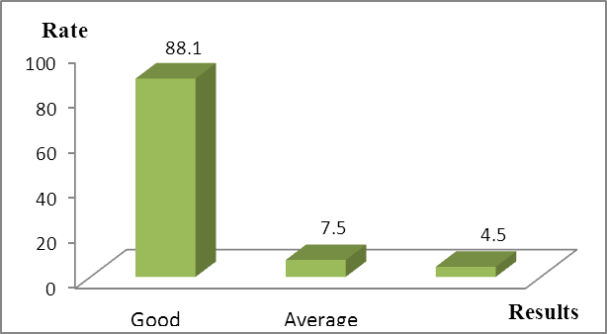

Chart 3.10: The postoperative position of the UDT

Comment: 57 children with 67 undescended testes were re-examinated after orchiopexy. The results showed 88.1% of testes in good position, 4.5% of testes in the bad positions.

Table 3.35: Average testicular volume after orchiopexy

|  |  |  |
| --- | --- | --- |
| **testicular volume** | **Pre-operation** | **12 months post- operation** |
| Right side | 0.65±0.29 cm3 | 0.84±0.32 cm3 |
| Left side | 0.63 ±0.33 cm3 | 0.75±0.30 cm3 |
| p < 0.05 | | |

***Comment:*** At 12 month post-operation, testicular volumes were bigger than their preoperative volumes. The trend was statistically significant, p < 0.05.

**Chapter 4**

**DISCUSSION**

**4.1. EARLY DIAGNOSIS AND INCIDENCE OF CRYPTORCHIDISM AFTER BIRTH**

**4.1.1. The early diagnosis of cryptorchidism**

Early diagnosis that we performed was diagnosis right after birth. The examination and early diagnosis after birth have been considered as an initial screening method to determine the rate of cryptorchidism. Using the imaging investigations for the cryptorchidism diagnosis in the newborn is not necessary. In this study, we determined the diagnosis of cryptorchidism after birth by clinical examination; this is a suitable approach with the authors in Vietnam and in the world.

**4.1.2. The incidence of cryptorchidism**

Our incidence of cryptorchidism’s postpartum was 4.8% similar to the result from Berkowit’s research (around 3.7%); Thong MK research was 4.8%; Preiksa’s rate was 5.7%. This is confirmed that cryptorchidism is the very popular congenital defect identified after birth in male children in our country as well as in the world. Cryptorchidism rate was 2.4% in fullterm and 25.1% in preterm infants. Thong M.K in 1998 showed that the rate of cryptorchidism was 17.3% in pre-term infants and 3.3% in full-term babies. Preiksa et al in 2005 noted that the rate of cryptorchidism in preterm and low birth weight infants was higher than in full term infants, with p = 0.03.

78.1% of full-term patients had cryptorchidism in one side, in contrast, mostly (71.5%) of cases in preterm had cryptorchidism in two sides. Thong M.K et al reported that the rate of cryptorchidism one side in fullterm babies was 72.7% while the rate of cryptorchidism two sides in preterm infants accounted for 76.9%. Additionally, Preiksa showed that cryptorchidism two sides in premature infants were higher in fullterm infants, with OR = 3.8.

In this project, we found that locations of cryptorchidism in preterm infants were at the inguinal canal and external inguinal ring (88.7%). In fullterm patients, cryptorchidism’s positions were at the inguinal canal and nonpalpable, accounted for 94.5%. We also detected the combined birth defects in 18.4% of cryptorchidism cases. The anomalies consisted of congenital malformations involving in the external genitalia such as hydrocell, inguinal hernia, hypospadias. A research of Thong M.K et al showed that these malformations in the children with cryptorchidism were in 16.6% of cases. Also Preiksa et al pointed that the rate of the external genitalia deformities in children with cryptorchidism was 21.7% while Machetti et al in 2012 reported that this rate was 18%. Therefore, cryptorchidism patients often have combined congenital malformations related to external genitalia.

**4.2. CRYPTORCHIDISM’S PROGRESSION IN THE FIRST YEAR**

**4.2.1. Spontaneous testicular descent in the first year**

The incidence of cryptorchidism quickly reduced from 368 neonatal patients to 161 infants at 3 months, to 128 infants at 6 months, and decreased 4 cases more at 6-12 months. The number of testes went down from 530 UDT at birth to 200 at 3 months, to 156 at 6 months, and to 152 at 12 months of age. The results showed that cryptorchidism mainly descended in the first three months, kept going down in 3-6 months, but slower even not moved after 6-12 months of age. Our results agreed with the Pyola S’s publication in 1995 that in most cases, the cryptorchidism descended into the scrotum in the first 3 months, less descent after 3-6 months, and after 6 months only under 5% of cases testes descended in the scrotum. Our results showed that the rate of cryptorchidism was 1.3% at 12 months. This result was similar to that of Berkowit (1.1%), of Thong M.K (1.1%), and of Peiksa (1.4%).

In preterm babies, cryptorchidism postpartum spontaneously descended in 88.3% of cases at 12 months. Cryptorchidism in full-term infants spontaneously descended in 39.8% of cases at 12 months. This result was similar to the results of Berkowit: cryptorchidism in preterm infants moving down to the scrotum in first years was 91.2%, inversely, that rate in fullterm infants was 57.1%. A similar result from Thong M.K research in 1998, the rates were 91% and 69.6%, respectively. The success rate of cryptorchidism at the external inguinal ring descended into scrotum was 96.3%. That rate at the inguinal canal was 81.3% , and only 35.2% of cases with cryptorchidism at internal inguinal ring and nonpalpable gained the success descent. As such, the position of testicles the closer to the scrotum, the more easily down to scrotum. The results implied higher success in the shorter distal testis. In the preterm infants, position of cryptorchidism was mainly at the external inguinal ring and inguinal canal, accounted for 88.7% while in the fullterm infants positions of cryptorchidism were mainly at the inguinal canal and nonpalpable, accounted for 94.5%.

Cryptorchidism’s volume at 12 months was smaller than that at the normal infants at the same age, with p < 0.05. A study of Thai Minh Sam reported that the size of cryptorchidism was smaller than normal testis size at the same age boys, with statistical significance (p < 0.001). If the patients were treated, the testis size would be more decreased. Quan T.L reported that by testis measurement in ultrasound, the older age patients were, the smaller testis volumes would be. In the 1-2 year UDT group, testes were rarely shrunken. In another research, Lee P.A et al investigated 166 patients with cryptorchidism and found 60% of those had testes smaller than normal size compared to that of boys at the same age. The testis size less changed in the patient group of 12-18 months of age.

**4.3. TREATMENT OF CRYPTORCHIDISM**

**4.3.1. Hormonal therapy**

We diagnosed cryptorchidism just after birth and tracked movement of cryptorchidism in the first year, then planned to give them hormonal treatment when they were at 12-15 months of age. Our patients were given the treatment much sooner compared to other study’s groups. This proves the diagnosis, monitor, and early treatment were useful for the patients. In this study, we identified 39.3% of cases with cryptorchidism location at the inguinal canal, 36.1% at the external inguinal ring, 11.5% at the internal inguinal ring, and 13.1% of them with non-palpable testes.

In another study, An N.T showed cryptorchidism’s position at the external inguinal ring was seen in 2.7% of cases, and 31.3% of them in the abdomen. It is inferred that there was diagnosed missing at birth and their families did not return their children to medical centers for treatment.

We diagnosed and immediately monitored the boys with cryptorchidism just after birth, consulted parents for early treatment of their boys. This may be a reason that our patients had been returned to get treatment. Through 2 treatment stages by HCG, the completely testis descent rate gained 30.3%; 28.7% of cases testes partly descended and made easy for surgery, and 41% of patients without changes. The cryptorchidism locus at the external inguinal ring very well responded to hormonal therapy, and the success rate reached 72.7%. Compared to study results from An N.T in 2000, the cryptorchidism at the external inguinal ring was successfully treated by hormone therapy in 75% of patients. The success rate of hormonal treatment for cases with cryptorchidism at the inguinal canal and internal inguinal ring were 8.4% and 6.9%, respectively.

In another study, Quan T.L et al recognized that the success rate of hormonal therapy for patients with cryptorchidism position at the external inguinal ring was 71.4%, and at inguinal canal was 9.8%. By clinical examination, palpable cryptorchidism responded hormonal therapy in 61.3% of cases and nonpalpable cryptorchidism was 43.7% of patients but the difference was not statistically significant (p = 0.1). This trend was also seen in the studies of An N.T in 2000 and Quan T.L in 2013.

We found that the average volume of cryptorchidism after 6 months hormonal therapy had risen compared to pre-treatment, but no statistical difference was reported, with p > 0.05. Minh N.T.N compared cryptorchidism volume via ultrasound before to after hormonal therapy 6 months, and also reported similar results, 0.48cm3 to 0.59 cm3, respectively (p > 0.05). Therefore, hormonal therapy helps to increase the testes volume.

**4.3.2. Surgical treatment**

In our study, the most common location of cryptorchidism was in the inguinal canal (42.4%) and non-palpable testes was about 2% of cases. We identified 32.3% of patients with cryptorchidism at the external inguinal ring. This rate was higher than that in previous studies. This may explain that we made very early diagnosis at birth, follow-up, hormonal treatment, and early consultant. Therefore, parents early returned their boys to receive orchiopexy before the boys were 2 years old. This saved time and avoid testis retrogression. All cases with cryptorchidism at the external inguinal ring and the inguinal canal were successfully operated at stage 1. The success rate of orchiopexy in cases with cryptorchidism at the internal inguinal ring was 80% (12/15 cases).

According to research of Viet H.T and Truong L.V, 100% of cases  the testes were in the good position if they underwent orchiopexy before age 2. The rate of 2 stage surgery was low (6% of cases) in our study. Because of our younger patients and the shorter distance from testis to the scrotum, it made easier success.

Truong L.V noted the cryptorchidism rate required 2 stage surgery increased by age: no patients at 1-2 years, 2.4% of patients at 2-4 years,11.4% of cases at 4-6 years, 26.2% of cases at 6-10 years , and 21.2% of cases at 10-16 years. So higher orchiopexy success was reported in shorter distal cryptorchidism in infants under 2 years old. A few complications detected in our study consisted of a missed sewing 1/82 patients (1.2%), and re-sewing post-operation 1 day. Paul J.K et al in 2010 noted that the rate of orchiopexy complications was 0.6%; no differences between orchiopexy complications in patients younger and older 2 years old.

Post-operative testis position in the scrotum (the good position) was noted in 88.1% of cases; the average position was in 7.4% of cases, and the bad location was in 4.5% of cases. Testicular volume at post-operation 12 months was larger than that was at pre-operation, with < p 0.05. Compared to the research results of Hai L.T et al in 2006, testis position in the good position was in 75.3% of cases; the average position was in 13.6%; and the bad locus was in 3.3%; and un-identification was in7.8% of patients. The similar results were reported in Tien H.V in 2007, with the rate of 69.8%, 23.6%, 4.3%, and 2.3%, respectively; and Truong L.V et al in 2013, with the rate of good, average, and bad positions were 78%, 18%, 4%, respectively. However, our results shows that the rate of post-operative testes at the good position were considerably higher compared to that from other authors. This may be our patients were used hormonal therapy, so testes descended lower positions and made orchiopexy easier to success. Furthermore, our patient's surgery age was lowest so it is likely reasonable for higher success rate.

**THE CONCLUSION**

Through the study of the early diagnosis cryptorchidism, follow up patients in the first year, treatment for patients at 1-2 years we draw some conclusions:

**1. Early diagnosis, incidence of cryptorchidism.**

***1.1. Early diagnosis***

Early diagnosis of cryptorchidism made immediately at birth by clinical examination was enough and without difficulties.

***1.2. The incidence of postpartum cryptorchidism***

- The incidence of general cryptorchidism was 4.8% in which 25.1% was in preterm infants, and 2.4% was in fullterm infants

- Cryptorchidism in low birth weight and preterm infants were mostly in both sides, inversely, fullterm boys were mainly in one side.

- Cryptorchidism position in preterm infants at the external inguinal ring and the inguinal canal accounted for 88.7% of cases. In fullterm boys, it’s location at the inguinal canal and nonpalpable was in 94.6% of cases.

**2. Cryptorchidism’s progression in the first year**

- 71.3% of cryptorchidism spontaneously descended into the scrotum in the first year, mainly in the first 3 months. After 6 months, most of testes itself did not descend .

- Cryptorchidism at the external inguinal ring descended into the scrotum in 96.3% of cases, in the inguinal canal went down in 81.3%, and in the internal inguinal ring and non-palpable in 35.2% of cases.

- Cryptorchidism descended into the scrotum in 88.3% of preterm cases in first year, and 40% of full-term patients.

-The average testicular volume measured on ultrasound was smaller than the average testicular volume at boys at the same age. This trend was clearly seen in cases over 12 months.

**3. Treatment results**

***3.1. Results of hormonal therapy***

- Hormonal therapy made cryptorchidism descent into the scrotum without surgery in 30.3% of cases, partly descent in 29.5% of cases, and no descent in 40.2% of cases.

- The success rate of hormonal therapy for cryptorchidism at the external inguinal ring was 72.7%, at the inguinal canal was 10.4%. Cryptorchidism in the internal inguinal ring and abdomen difficultly descended to the scrotum.

- 59% of cryptorchidism cases responded to hormonal therapy, The results also saw in cases with palpable and non-palpable testes.

***3.2. Results of treatment by surgery***

- The success rate of orchiopexy before age 2 was 92%.

- 92% of cases with orchiopexy before age 2 had normal post-operation testis density.

- Complication rate of orchiopexy before 2 years was 1.2% and complications were mild.

- The average volume of cryptorchidism operated before age 2 markedly increased compared to after operation 12 months.

**RECOMMENDATIONS**

1. The doctors and midwifes of all the Pediatric - Obstetric facilities, vacc As such, the position of testicles the closer to the scrotum, the more easily down to scrotum ination centers should be responsible for examination and screening all boys at birth to detect cryptorchidism.  It is necessary to consult for parents of the cryptorchidism postpartum boys about the importance of early treatment and sending them to see pediatricians at 6-9 months for diagnosis and early treatment plans.

2. It is necessary to have a clear strategy for early detection of cryptorchidism at neonatal period. We should strengthen the training and retraining of knowledge about cryptorchidism for all medical staff.

3. It is necessary to broadly propagate to the parents about usefulness and safety of the early treatment for cryptorchidism patients before 2 years . Hormonal therapy should be conducted at 9-12 months. If hormonal therapy failed, orchiopexy should be performed before patients being 2 years old.