1. INTRODUCTION
Hand Foot and Mouth disease (HFMD) is an infectious disease transmitted from human to human, caused by enterovirus and easily to become epidemic. HFMD is common in children under 5 year old, transmitted mostly by intestinal route, directly mouth-mouth or feces- mouth. Since 1990s, many HFMD outbreaks have been reported in South East Asia Pacific countries with fatal complications such as meningo- encephalitis, myocarditis, pulmonary oedema, even leading to deaths. In 2008, there was a HFMD outbreak in Taiwan with 347 severe and complication cases and 14 deaths. In 2009, 1.1555.525 HFMD cases were reported in China including 13 810 severe cases and 353 deaths.
Until now, there has not been specific treatment, therefore the world tendency is to develop vaccin, early diagnosis and treatment to reduce mortality. In Vietnam, HFMD epidemics often occur, may be sporadic or spread. In HFMD outbreak in 2011, 113 121 cases including 170 deaths were reported. There were some studies on HFMD epidemiology and clinical characteristics in Vietnam. However, these studies were conducted only in a few provinces and in short term, so could not be representative for the whole country. Moreover, their results were limited in diagnosis, not analysed in depth predictive factors as well as clinical features caused by each EV genotypes, that led to limitations in HFMD treatment and prevention in Vietnam. Aiming to provide a overall description on HFMD, on its common causal agents as well clinical features and common complications in order to help to prevent the disease and reduce its mortality, the study “To study clinical, subclinical features and causal viruses of Hand Foot and Mouth disease in Vietnam” was conducted with 3 objectives:
- To evaluate clinical and subclinical features of HFMD in Vietnam
- To identify the main causal viruses of the disease
- To analysis risk factors related to the severity and complications of HFMD.
The data was from the National study on HFMD led by the National hospital on Infectious and Tropical diseases, named: “To study HFMD epidemiology, clinical features, diagnosis, treatment and prevention in Vietnam” with the authorization from the study leader.
2. NEW FINDINGS OF THE THESIS
- This was the first thesis on HFMD conducted at the same time in leading hospitals in whole coutry, so provided a overall description on HFMD clinical, subclinical and causal viruses characteristics in Vietnam.
- The study identified 2 main enteroviruses (EV) causing HFMD, composing EV71 with predominant C4 subgenotype, and Coxsackieviruses with predominant CA6 subgenotype. The result also showed EV71 pathogenic role during this time period.
3. PRACTICAL VALUE OF THE THESIS
- The study identified HFMD predictive factors that help clinicians in following patients and to give intervention in time to reduce the mortality.
- The study identified EV71 subgenotype C4 as the main causal virus. It was also the main cause of severity and complications, therefore could be selected as the candidate for HFMD vaccin development.
4. THE LAY OUT OF THE THESIS
The dissertation consist of 131 pages (excluding appendice), including Introduction (2 pages), Overview (40 pages), Subjects and Study methods (20 pages), Results (36 pages), Discussion (30 pages), Conclusion (2 pages), Recommendations (1 page), 42 tables, 21 charts, 10 photos and 120 references.
CHAPTER 1: OVERVIEW
1.1. Situation of Hand Foot and Mouth disease (HFMD)
The disease was first described in Toronto-Canada in 1957. It was called Hand Foot and Mouth disease during an epidemic in Birmingham- England in 1959. With Coxsackie A16, EV71 were the main cause of the disease. Since the end of 1990s, HFMD outbreaks occured in Pacific Asian countries such as China, Singapore, Taiwan, Malaysia with a number of CNS, cardiac and pulmonary complications.
In Vietnam, HFMD occurs sporadically during the year in almost provinces especially in the South. An HFMD outbreak was reported in 2011 with 113121 cases including 170 deaths.
1.2. Etiology
Enterovirus cause HFMD
Enterovirus is 1 among 7 genus belonging to Picornaviridae family, Picornavirales order, a large group of a single positive-strand genomic RNA. The enteroviruses are icosahedral nonenveloped viruses that are approximately 30 nm in diameter. They have a capsid composed of 60 subunits, each formed from 4 proteins (VP1 to VP4). A linear, single-strand RNA genome of about 7.4 kb is enclosed by the capsid; the translation product is a single polyprotein that is cleaved after translation by viral-coded proteases into the structural proteins (VP1 to VP4), RNA polymerase, proteases, and other nonstructural proteins. There is a VPg protein 5’untranslated region composing ribosom- binding sequence type I (IRES). P1 region encodes structure proteins. P2 and P3 region encode nonstructure proteins relating to virus replication. 5’ UTR is followed by 3’ UTR and poly A tail. 3’ UTR has important role in minus-strand RNA synthesis.
Without lipid envelope, enterovirus are stable at enviromental condition like stomach pH. They can exist in the room temperature for some days. Enteroviruses resist to lipid dissolution solven (as ether and chloroform), ethanol but are inactive at temperature of over 56⁰C, clo, formaldehyde and ultra-violet ray..
Not all enteroviruses can cause HFMD. Common causes are EV71, Coxsackievirus, Echoviruses and some other enteroviruses. EV71 includes 4 genogroup A, B, C and D. A and D genogroup have only one subgenotype for each. That of subgroup A is BrCr. Genogroup B is divided into 6 subgenotypes: B1–5 and B0. Genogroup C is divided into 5 subgenotypes: C1-5.
Coxsackieviruses are divided into 2 subgroups A and B. Subgroup A includes 24 subgenotypes caussing diseases for human, among that CA16 is one critical cause of HFMD. Other subgenotypes can cause HFMD including CA5, CA6, CA7, CA9 and CA10 . Coxsackievirus B subgroup includes 6 subgenotypes among that B1, B2, B3, B5 can also cause HFMD.
Transmission route:
- HFMD occurs in all ages, but commonly in children. Human is the only source. The disease is transmitted directly from human to human predominantly by feca-oral route, and may be transmitted through respiratory-oral route by direct contact with nasal droplets, saliva and skin vesicles or indirect contact through the patients toys, house items and floor..infected of their discharge. HFMD occurs sporadically in whole year but more frequently in the summer and autumn. The disease is common in poor hygien countries.
1.3. Clinical, subclinical feature, diagnosis and treatment of Hand Foot and Mouth disease.
1.3.1. Clinical symtoms
Specific symtoms include: not high fever, rash in specific sites (around mouth, palms, soles, buttock and knees), mouth ulcers, bowel disorders (vomit, diarhea).
Most patient develop benign and recover spontanely within 7-10 days if there aren’t complications.
1.3.2. Complications
- CNS complication: encephalitis, brain stem encephalitis, meningoencephalitis and menigitis. Common symptoms are frequent myoclonus jerk, tremors, ataxia, nystagmus, seizure and coma.
- Cardiac complication: myocarditis, heart faillure. Common symptoms are tarchycardia, hypertension followed by hypotension and shock.
- Respiratory complication: pneumonia, OAP. Common symptoms are short breaths, dyspnea, leading to respiratory faillure.
1.3.3. Subclinical tests
1.3.3.1. Biochemical and hematological exams
WBC nornal or lightly increased. CRP normal or lightly increased. VS often increased. CSF disorder when CNS complication occurs (pleocytes with hypermonocytosis, lightly increased protein).
1.3.3.2. Imaging findings.
Celebral CT and MRI help to define lesions location in the brain. Cardioechography, ECG and Troponin I should be done to detect myocarditis and cardiac shock. Chest X ray performed when respiratory complication suspected. Common lesions on X ray are interstitial pneumonia or bilateral infiltrate in pulmonary oedema.
1.3.3.3. Etiology diagnosis test
- Technics PCR (Polymerase chain reaction), RT-PCR (Reverse Transcription Polymerase Chain Reaction) are commonly applied as high sensitivity and specificity.
- Sequencing technic: permit to define EV genotypes and subgenotypes.
- Virus isolate by culture: require long time and high technic. Define EV71serotypes after culture by neutralization test using specific antibody for each serotypes.
- Technic of immunoglobulin IgM detection of EV71 is being developed but may have false positive and not high sensitivity.
- Indirect immunofluorescence assay (IFA) tests using anti-EV71 monoclonal antibodies can provide rapid result, but with high expense.
1.3.4. Diagnosis confirmation
- Epidemiology: based on age, season, epidemic areas, number of infected children at the same time.
- Clinical: specific rash and vesicular on mouth, palm, sole , knee and buttock, with or without fever.
- Confimatiory test: RT-PCR or isolated test for EV is positive.
1.3.5. Treatmen and prevention
There is not yet specific treatment for HFMD. Symptom treatment, follow-up to detect and control complications.
Prevention: there is not yet HFMD vaccine. Prevention mostly by hygien keeping and contaminated source avoiding.

CHAPTER 2: STUDY SUBJECTS AND METHODS
2.1. Study period and sites
2.1.1. Time period for patients inclusion: from August 2011 to December 2012.
2.1.2. Study sites: patients enrolled from 5 leading hospitals representative for the whole country:
- In the North:
- National hospital for Tropical diseases
- National Pediatric Hospital
- In the South:
- Pediatric Hospital 1
- Pediatric Hospital 2
- HCMC Hospital for Tropical disease.
2.2. Study subjects
2.2.1. Inclusion criteria
All patients having enough 3 following criteria:
a/ Be confirmly diagnosed of HFMD according to WHO and MOH guidlines (2011), including:
- Clinical: patients living in epidemic areas and presenting one or more HFMD clinical symptoms: fever, rash on specific sites, mouth ulcers.
- Tests: patients having throat fluid RT-PCR positive with enterovirus.
b/ Patients admitted to hospital and be followed until they are stable.
c/ Patients parents or family members approve of patient participating to the study.
2.2.2. Exclusion criteria
- Patients evidently infected of other infectious disease at the point of enrollment.
- Patients infected or exposured to HIV.
- Patients not followed up at hospital until stable.
2.3. Study methods
2.3.1. Study design: Cross descriptive study with analysis.
2.3.2. Sample size and sample selection
a. Sample size
- Sample size estimated base on calculation formula of cross study:
n = Z² _{(1-α/2)} p. (1-p)/(d)²
Among that:
n: number of patients
p: prevalence of EV positive test. According some report in Vietnam, prevalence of EV positive test with specimen from throat fluid were over 50%, therefore we took p = 0,5.
Z: 1,96 with α = 0,05.
d: absolute exactitude.
Using WHO sample size estimation tool version 2.00 , with d = 0.05 and 1- α = 95, we have the minimum sample size = 385.
b. Sample selection
Full sample size. All clinical suspected cases were screened for oral swab test. Specimens were stored at each hospital then were transferred to National Hospital for Tropical diseases for RT-PCR test to define causal viruses.
Only clinical cases having oral swab RT-PCR positive test were selected for the study.
c. HFMD severe and complication cases definition
- Severe cases: defined if patients at clinical grade of 2B or more according to MOH guideline (2011)
- Complication cases: defined if patients having following criteria:
+ Clinical grade of 2B or more .
+ At least one among neurological, cardiac and pulmonary complications.
2.3.3. Study procedure
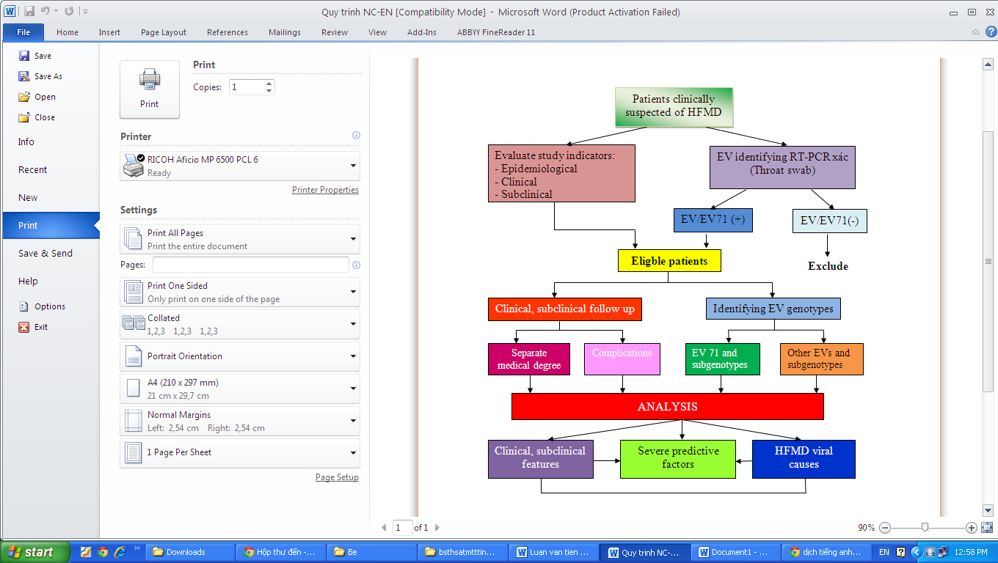
Diagram 2.1. Study procedure
2.4. Ethical cosideration
The study was one part of the National level study led by the National Hospital for Tropical disease, that received the approval from the hospital IRB committee.
2.5. Data analysis
The collected data was analysed by statistic sofware SPSS version 18.0. Statistic threshold p=0,05 for all analysis tests.
2.6. Study limitation
The study was limited in hospitalized patients. The number of inpatiens of the North much lower than that of the South, therefore we could not compare clinical features of the two patient groups.

CHAPTER 3: STUDY RESULTS
1170 HFMD inpatients from 50/64 provinces of the whole country eligible for the study. The results as following:
3.1. HFMD clinical and subclinical features
3.1.1. Study population information
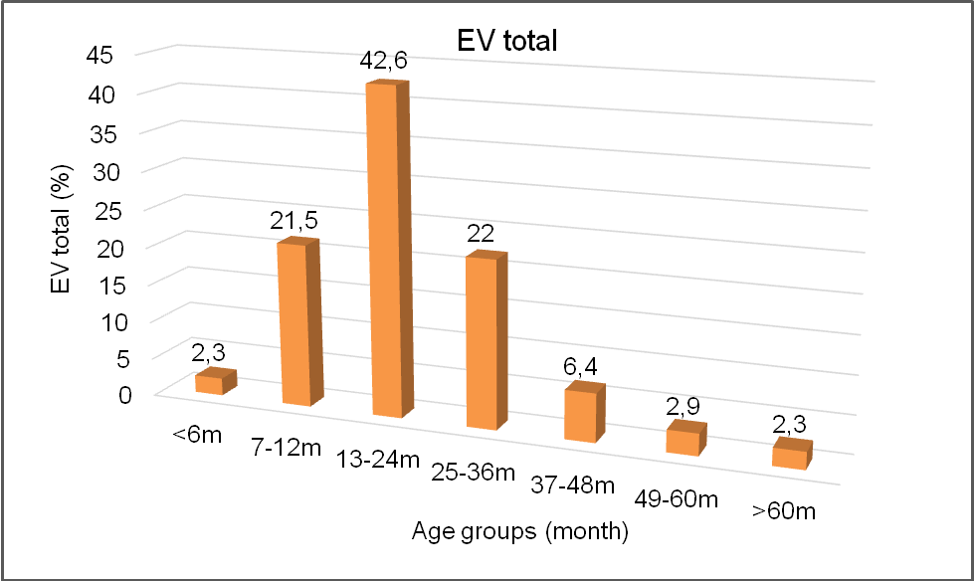
Chart 3.1. Age distribution
97,7% patients under 60 age months (5 year old), including 88,4% children from under 36 months (3 year old).
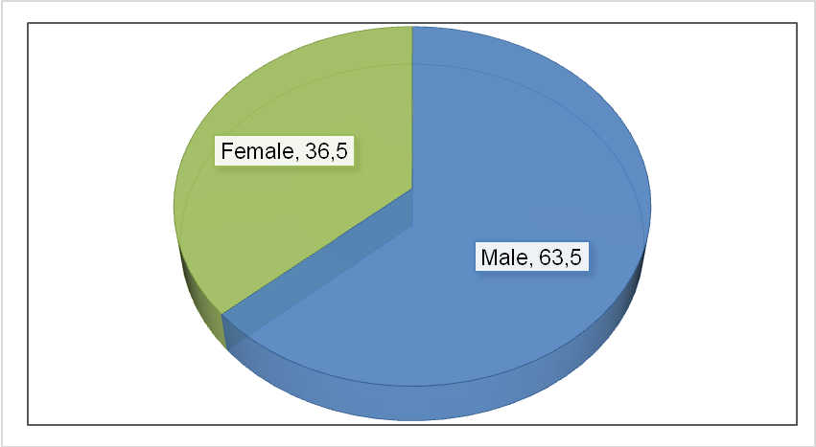
Chart 3.2. Sex distribution
The male patients took 63,5%, higher than the female (36,5%). Male/female ratio was 1,7:1.
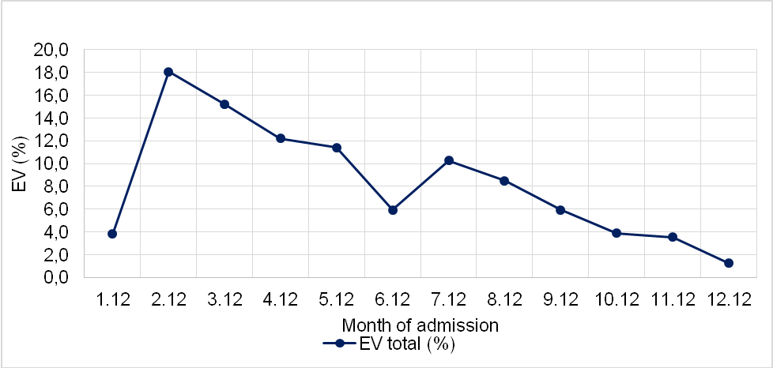
Chart 3.4. HFMD distribution at admission point during 2012
During the year 2012, HFMD patients admitted sporadically in all months, more frequenly in the spring (February to April) and begin of autumn (July to September).
3.1.2. HFMD clinical features
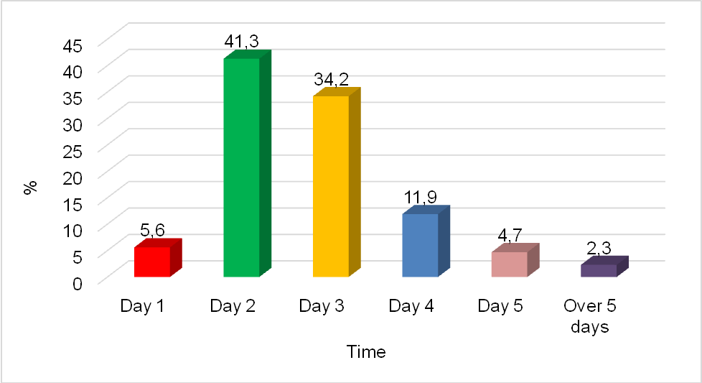
Chart 3.6. Time from clinical beginning to admission point
Most HFMD patients admitted in the first 4 days of the disease (93%).
Table 3.2. The HFMD common symptoms
Symptoms | n = 1170 | %
Rash | 1070 | 91,5
Oral ulcer | 865 | 73,9
Fever | 726 | 62,1
Myoclonus | 601 | 51,4
Vomit | 159 | 13,6
Diarhea | 62 | 5,3
HFMD common clinical symptoms were: rash (91,5%), oral ulcer (73,9%), fever (62,1%) and myoclonus ( 51,4%).
Intestinal symptoms such as vomit and diarhea took low prevalences (13,6% and 5,3%).
3.1.2.4. Clinical grade
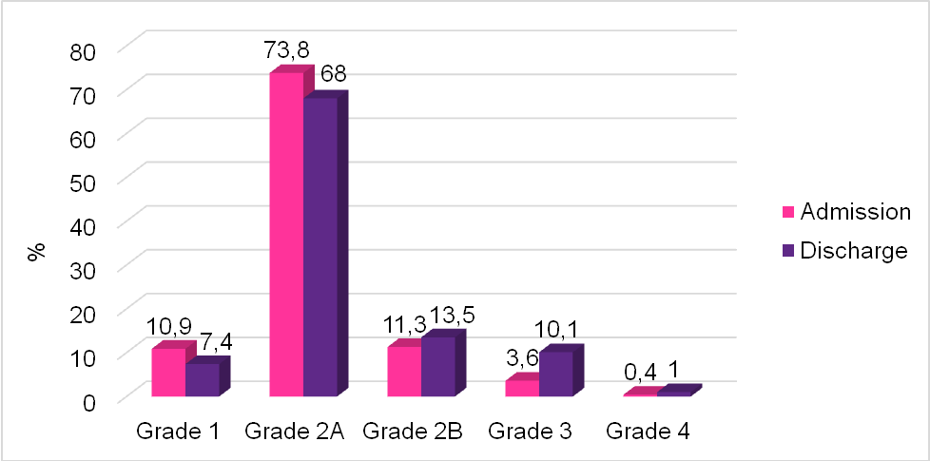
Chart 3.7. Clinical grade
Patients admitted at all 4 clinical grade, mostly at grade 2A (73,8%). 15,3% patients admitted at severe situation (at grade 2B, grade 3 or grade 4).
3.1.2.5. Clinical grade progression during admission
Table 3.4. Clinical grade progression during admission
Grade at admission | Grade to wich illness progressed (%)
Grade at admission | Grade2A | Grade2B | Grade 3 | Grade 4 | Total
Grade 1(n=128) | 41,9 | 1,2 | 5,8 | 0 | 48,9
Grade 2A(n=863) | - | 7,1 | 4,6 | 0,2 | 11,9
Grade 2B (n=132) | - | - | 25,8 | 1,5 | 27,3
Grade 3(n=42) | - | - | - | 7,1 | 7,1
Prevalence of patients progressed to higher grade during admission from grade 1, 2A, 2B and grade 3 were 31,4%, 11,9%, 27,3% and 7,1%, respectively.
3.1.3. HFMD complications
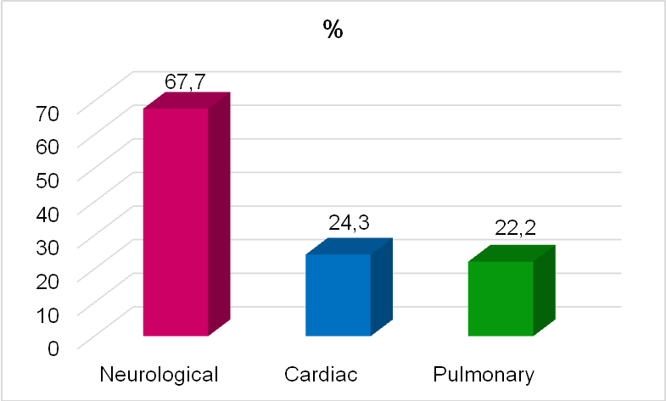
Chart 3.8. HFMD complications (n=288)
Of the total 1170 patients, 288 ones having complications (24,6%). Among that, neurological one was the most common (67,7%). Cardiac and pulmonary complications were less common, taking 24,3% and 22,2%, respectively.
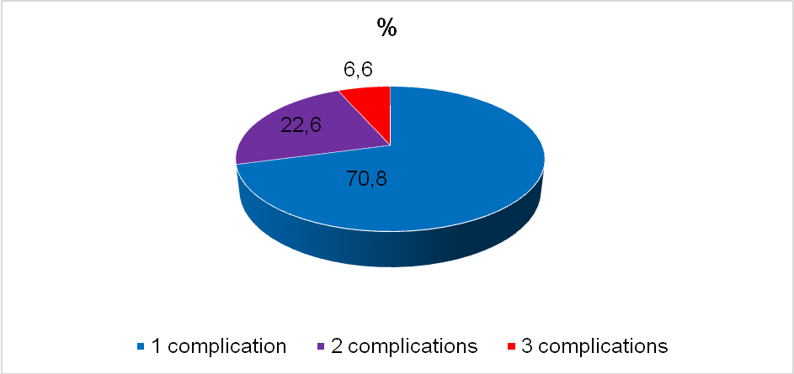
Chart 3.9. Complication prevalence
Of patients having neurological, cardiac or pulmonary complications:
- 70,8% patients having 1 complication.
- 22,6% patients having 2 of the 3 complications combined.
- 6,6% patients having all the 3 complications
3.1.4. HFMD subclinical features
3.1.4.1. Hematological test
Table 3.7. Chages in WBC, Platlet counts and VS
Indicators | Counts | n | %
WBC  (n=724) | >16 000 cells/mm³  10-16000cells/mm³  <10000 cells/mm³ | 151  358  215 | 20,9  49,4  29,7
WBC  (n=724) | Median ± SD: 12613±4492 cells/mm³  Variance: 2190- 29 950 cells/mm³
Platlet  (n=725) | ≤ 400 000 tb/mm³  >400 000 tb/mm³ | 592  133 | 71,7  18,3
Platlet  (n=725) | Median ±SD: 323 646 ± 94 980 cells/mm³  Variance: 41 900 – 702 000 cells/mm³
VS  (n=124) | Increased | 117 | 94,4
VS  (n=124) | Median ±SD: 38,3± 21,4 mm/h  Variance: 2 - 264 mm/h.
20,9% had WBC increased over 16 000 cells/mm³. 18,3% had platlet count over > 40000 cells/mm³. 94,4% had increased VS.
3.1.4.2. Biochemical test
Table 3.8. Biochemical test results
Indicators | Increased |  | Median | Variance
Indicators | n | % | Median | Variance
Glucose (mmol/l) (n=468) | 101 | 21,6 | 5,6 ± 2,2 | 2,0 - 27,9
AST (U/L) (n=179) | 58 | 32,4 | 41,3 ± 28,3 | 17,5 - 340
ALT (U/L) (n=179) | 13 | 7,3 | 24,0 ± 30,1 | 6,1 - 270
CK (U/L) (n=234) | 17 | 7,2 | 59,5±16 | - 1410
Troponin I (n=26) | 2 cases positive, taking 7,7%
32,4% had increased AST , 21,6% had increased glycemia
3.2. HFMD viral causes
3.2.1. RT-PCR test detecting EV71 and other EVs
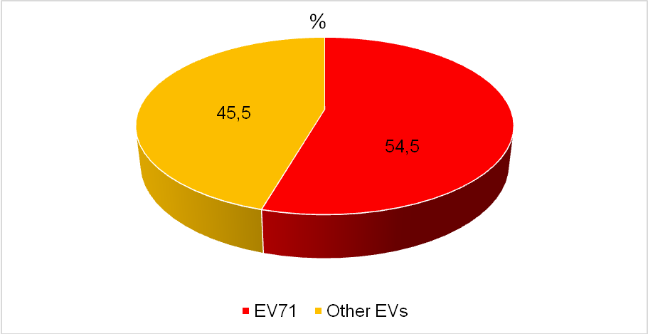
Chart 3.12. EV71 and other EVs prevalence by RT-PCR
1170 oral swab specimens were tested for EV by RT-PCR. Result was: EV71(638/1170) taking 54,5%; other EVs (532/1170) taking 45,5%.
3.2.2. Result of sequecing test
3.2.2.1. Identifying HFMD causing EV subgroups
Table 3.12. Prevalence of EV subgroups
EV groups | n | %
EV 71 | 484 | 68,2
Coxsackievirus | 179 | 25,2
Echovirus | 15 | 2,1
Other EV groups | 32 | 4,5
Total | 710 | 100
EV71 and Coxsackievirus were 2 main causes of HFMD.
Besides, Echovirus and other EVs also presented in the study.

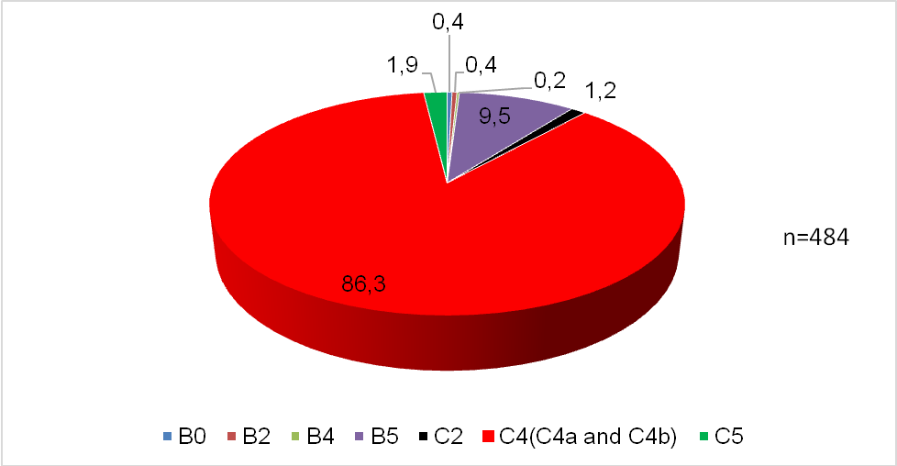
Chart 3.13. EV71 subgenotypes prevalence
Of all EV71 cases, C genogroup identified including subgenotypes C2, C4, C5, with C4 subgenotype (including C4A and C4B) was at highest prevalence (86,3%). EV71 genogroup B included B0, B2, B4, B5 subgenotypes, with B5 subgenotypes was at highest (9,5%), the rest took only from 0,2% to 1,9%.
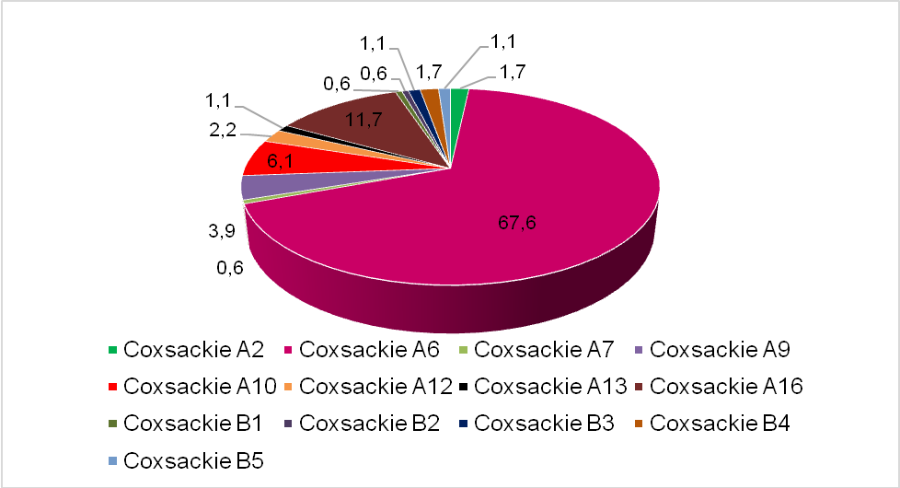
Chart 3.14. Coxsackievirus subgenotypes prevalence
HFMD causing Coxsackievirusé included Coxsackievirus subgroup A (2,6,7,9,10,13,16) and Coxsackievirus subgroup B (1,2,3,4,5). Of that, Coxsackie A6 was the most common (67,6%), followed by Coxsackie A16 (11,7%), then Coxsackie A10 with 6,1%.

3.2.2.2. EV main subgenotypes causing HFMD
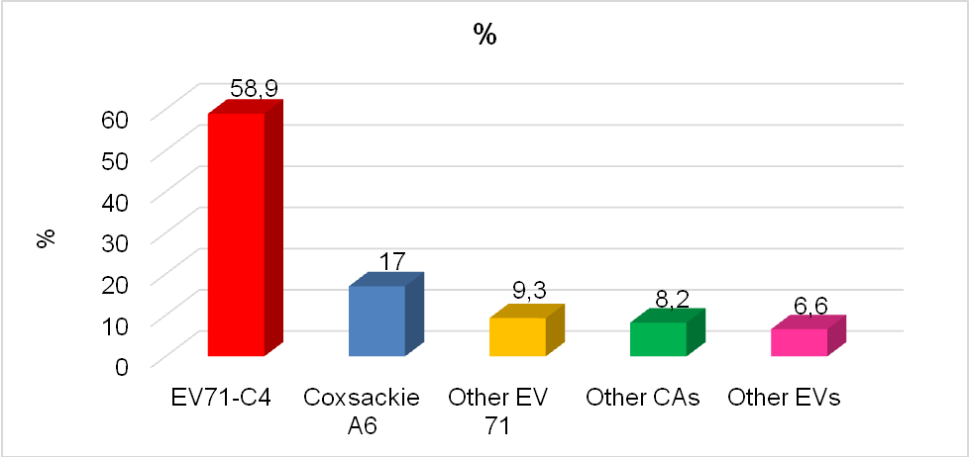
n=710
Chart 3.15. EV main subgenotypes causing HFMD
Of the total 710 specimens sucessfully done sequencing test for EV subgenotypes, EV71-C4 subgenotypes taking 58,9% and Coxsackie A6 taking 17% were define as 2 main EV subgenotypes causing HFMD in Vietnam.
3.3. HFMD predictive factors
3.3.1. Clinical symptoms associated with the disease severity.
The multivariate analysis showed the following factors associated with the disease severity: myoclonus , not oral ulcer, high fever over 38,5ºC with p <0,05 and OR were 4,4(95%CI 3,2-6,1); 2,2(95%CI 1,6-3,0) and 2,7(95%CI 2,1-3,8), respectively .
3.3.2. Subclinical changes associated with the disease severity
The analysis on hematological indicators showed that proportion of HFMD patients having platelet counts over 400 000 cells/mm3 and WBC over 16000 cells/mm³ in severe group were significantly higher than that in not severe group with p < 0,05 and OR were 2,2(95%CI 1,5-3,3) and 1,5(95%CI 1,1-2,2), respectively.
The analysis on biochemical indicators showed that proportions of HFMD patients having increased AST and hyperglycemia in severe group were significantly higher than that in not severe group with p< 0,05 and OR were 2,4(95%CI 1,2-4,7) and 2,9(95%CI 1,8-4,6), respectively.
3.3.3. Causal virus associated with the disease severity and complications
Analysis on EV71 and other EVs patient groups showed that the proportion of severity and complication were significantly higher in the former group with p <0,05 and OR=2,2 (95%CI 1,6-2,9)
Proportions of neurological, pulmonary and cardiac complication in EV71 patients groups were significantly higher than that in other EVs group with p<0,05 and OR were 1,9 (95%CI 1,4-2,6) ; 2,5(95%CI 1,4-4,4) and 1,9(95%CI 1,1-3,2), significantly .
Analysis on genogroup B and genogroup C of EV71 showed that severity proportion in EV71 genogroup C was significantly higher than that in genogroup B with p <0,05 and OR=4,5(95%CI 1,9-8,7). Proportion of patients having neurological complication in genogroup C was 25,6%, significantly higher than 2,0 % in genogroup B (p <0,05). 7,2% patients in genogroup C had pulmonary complication while there weren’t any patients having this complication in genogroup B.
Analysis on EV71-C4 and CA6 patient groups showed that the severity proportion in the EV71-C4 patient group was higher than that in CA6 group. The difference was significant with p <0,05 and OR=6,2(95%CI 3,2-9,9). The proportions of neurological, pulmonary and cardiac complications among EV71-C4 infected patients was significantly higher than that of CA6 infected patients with p< 0,05 and OR were 4,4(95%CI 2,2-9,0) ; 6,8( 95%CI 2,2-9,0) and 5,4(95%CI (1,3-10,0), respectively.

CHAPTER 4: DISCUSSION
4.1. HFMD clinical, subclinical features and prognosis
4.1.1. Study population information
4.1.1.1. Age distribution
Result from the chart 3.1 showed that most admitted patients (97,7%) were from under 5 year old (60 months), including 88,4% among them from under 3 year old (36 months). Our result was equivalent to that of Phan Văn Tú’ study in the South of Vietnam in 2005 as well as previous studies in other countries in the area.
4.1.1.2. Sex distribution
In this study, HFMD male patients proportion was 63,5%, significantly higher than that of female patients (36,5%) (chart 3.2). Male/female ratio was 1,7:1. Study of Trương Hữu Khanh in the year 2011 also had similar result with 62% male patients.
4.1.1.4. Disease distribution at admission point during the year 2012
It was shown that HFMD cases admitted sporadically in all months of the year 2012, at 2 peaks being in the spring (February to April) then in the begin of the autumn (July to September), then decreased to the end of the year. Jin-feng Wang and colleagues found a significant association between the climate and HFMD occurrence. Our result was similar to that of the study conducted by Phan Văn Tú showing the number of HFMD admitted cases was highest in the February and March of the year.
4.1.2. Clinical features
4.1.2.2.Time from clinical beginning to admission point
Most patients (93%) admitted in the first 4 days of the disease. The result showed that HFMD progressed rapidly, therefore media education was necessary to recommend parents to follow up ill children carefully and transfer them to hospital timely.
4.1.2.3. Clinical symptoms and progression
HFMD clinical common symptoms were skin rash taking the highest proportion (91,5%), followed by oral ulcer (73,9%). Fever was the third with 62,1%. The result was suitable to MOH definition on HFMD wich may or may not have fever. Besides, HFMD patients had intestinal symptoms such as vomit taking 13,6% and diarhea taking 5,3%.
Studying on clinical symptom progression, we found that HFMD symptoms occurred early. Most symptoms occurred during the first 3 days of the disease, even more than 50% patients presented fever, oral ulcer and rash on the first day of the disease. These were clinical symptoms that help the disease early diagnosis.
- In the study, myoclonus was at the proportion of 51,4%. This prevalence was lower than that of previous studies conducted in the Pediatric Hospital 1(74,5%). The difference may be due to different inclusion criteria and study sites. The result showed that myoclonus was one earliest neurological sign in HFMD and was an important one that helps physicians to diagnose the disease and follow up patients to early detect severe situation.
4.1.2.4. Clinical grade progression during admission
The clinical grade proportions at admission point composed Grade 1 with 10,3%, grade 2A with 73,8%, grade 2B with 11,3%, grade 3 with 3,6% and grade 4 with only 0,4%. Truong Huu Khanh conducting a study on HFMD at Pediatric Hospital 1 in the year 2011 also reported similar results with proportions respectively of 17,73,9,1 and 0,4%. Proportions of clinical grades progressed from grade 1, grade 2A, 2B and grade 3 during hospitalizations were respectively 31,4%, 11,9%, 27,3% and 7,1%, also similar to the sudy of Truong Huu Khanh. This showed that HFMD patients should be followed up carefully during admission to be decteted early severe progression and be timely managed.
4.1.3. The disease complications
288 among total 1170 patients ( 24,6%) being at grade 2b and more and having severe signs were divided into neurological, cardiac and pulmonary complication groups. Among that groups, neurological one took the highest prevalence with 67,7%. Our result was equivalent to that of other authors in the country and area, showing that neurological complication was predominant in HFMD. Pulmonary and cardiac complications were less common with the respectively proportions of 22,2% and 24,3%. Some authors suggested that in HFMD nerological lesions were at brain stem, cardiac pulmonary center, therefore cardiac and pulmonary complications often followed neurological complications and were consequence of brain stem damages. However, the mechanism has been clear until now. We also found that patients could have combinations of neurological, cardiac and pulmonary complications.
4.1.4. Subclinical features
4.1.4.1.Hematological test
The blood formula results showed that over 50% patiens had WBC counts increased to more than 10 000 cells/mm³. Analysing WBC counts according to clinical grages, it was found that the proportions of patients having WBC counts increased to more than 16000 cells/mm³ in groups of clinical grade 2B and more were higher than that in groups of clinical grade 1 and 2A. Đoan Thi Ngoc Diep and Li also saw that in HFMD patient severe group WBC counts were often highly increased. Even Jiahua in a HFMD study in the year 2012 showed that WBC counts of over 17 000 cells/mm³ was one severe predictor. Like with WBC, our study also showed that the patients having platlet counts over 400 000 cells/mm³ seen in group of clinical grade 2B and more with higher proportion as compared to that in group of grade 1 và 2A. These are indicators to be analysed for severe predictive factors.
4.1.4.2. Biochemical test (table 3.8)
Our study showed that proportion of patients having hyperglycemia was 21,6% and increase AST was 32,4% while only 7,3% patients having increased ALT. Patients having increased CK took 7,2%. AST may be increased in liver injury and also in myocardiac injury. Therefore it is necessary to have more study on the mechanism of increased AST in HFMD.
4.2. HFMD viral causes
4.2.1. RT-PCR test detecting EV71 and other EVs
Of the total 1170 patients identified as EV infected by RT-PCR test, 638 ones positive with EV71 (taking 54,5%), 532 others were identified as other EVs infected (chiếm 45,5%) (chart 3.12). The result was equivalent to other studies in the area, showing that EV71 was the common cause in HFMD epidemics. When comparing to other datas in Vietnam, we found that previous reports on EV71 were often sporadically concentrated in some provinces. Our study may be one first and complete report on EV and EV71 infection in HFMD patients in the whole country.
4.2.2. Sequencing test detecting EV subgenotypes causing HFMD
It was showed that main enteroviruses causing HFMD in Vietnam composed EV71 at highest prevalance, followed by Coxsackievirus, Echovirus and other EVs.
Sequencing test to identify EV71 subgenotypes found that C4 subgenotype was predominant (86,3%), followed by B5 subgenotypes (9,5%). Lê Phan Kim Thoa in a HFMD study conducted in the South of Vietnam in 2011 also reported that EV71-C4 subgenotype took 94% of EV71 infected cases.
Sequencing test identified also Coxsackievirus A and B subgroups as HFMD viral causes in Vietnam. Among that, CA6 subgenotype was predominant (67,6%), followed by CA16 (11,7%). This is new point of the study because CA16 used to be reported as one most common cause of HFMD in previous studies in Vietnam. This result however was equivalent to HFMD conducted by Tsuguto in Japan in the year 2011, reporting CA6 subgenotype as HFMD predominant cause. That reflected the diversity of HFMD viral causes during different time periods.
4.3. HFMD predictive factors
4.3.1. Clinically
The multivariate analysis showed that clinical symptoms associated to the disease severity were high fever at > 38,5º C (OR=2,72), myoclonus (OR= 4,4) and no oral ulcer (OR=2,2), with p <0,05. The result was similar to previous studies conducted in the country and abroad as in China and Malaysia and provided more evidence for MOH guideline on HFMD, in that ill children with high fever at ≥ 39º C were graded at 2A and should be admitted for taking care. Studies by Phan Van Tu (2005) and by Trương Thị Triet Ngu (2007) reported that children having oral ulcers had more ability of Coxsackievirus infection than of EV71 infection so their clinical situations therefore were less severe. Besides, the study showed that not all patients having myoclonus at beginning developed to severe situation and neurological complication. MOH guideline classified patients at clinical grade 2B and more when patients presented myoclonus during examination with frequency of 2 times or more in 30 minuts. So physicians during clinical examination should not only detect myoclonus but also its frequency to identify neurological complication and severe situation in order to it timely control.
4.3.2. Subclinical
Analysis on association between hematological indicators and the disease severity showed that WBC counts > 16000 cells/mm³ and platlet counts > 400 000 cells/mm³ were severity predictive factors. This result was similar to previous studies in the area. May be the WBC and platlet counts increasing related to inflammatory reaction in HFMD. The more severe situation, the more inflammation was and the more WBC and platlet counts increased.
Analysis on the association between biochemical indicators and the disease severity showed that increased AST and hyperglycemia were severity predictive factors. Glycemia increased in severe patients may due to inflammatory mechanism in that catecholamin increased as the result of autonomy nervous system disorders. AST not only increased in liver injury but also in myocardiac injury. Was AST increasing an indicator of myocardiac injury in HFMD? This issue need more studies. However, the above results would help physicians to prognose for timely management and reducing the mortality.
4.3.3. Viral causes
It was found that EV71 patient group had severe case as well as neurological, cardiac and pulmonary complication proportion higher than that of other EVs patient group. Wang and colleagues studying in Shenzhen (China) reported that all severe cases in 2009 were infected by EV71. The result was similar to HFMD epidemic finding in 2011 in Vietnam. It was shown that patients in EV71 genogroup C had higher incidence of severe case and neurological, cardiac and pulmonary complications as compared to EV71 genogroup B patients. This was a new point of our study because there haven’t been any reports in Vietnam on comparison between EV71 genogroup B and genogroup C clinical features. Proportions of severe cases and complications in EV71-C4 infected group were higher than that in CA6 infected group. The result showed that in the HFMD epidemic in Vietnam in 2012, EV71 subgenotype C4 was the main cause of severe cases. This was similar to previous reports in the country and area on HFMD epidemiology and on EV71 including C4 pathogenicity. The above result provided more important epidemiological and clinical information, helping high risk causal viruses selection for the vaccin development studies.

CONCLUSION
1. HFMD clinical, subclinical features in Vietnam
- The disease occured in the whole year, at peak in the spring (Feb-Apr) and at the begin of autumn (Jul- Sep), mostly in children from under 5 year old (97,7%) including 88,4% of under 3 year old. Male patients were predominant (63,5%). Male/female ratio was 1,7:1.
- Most patients admitted in the firrs 4 days of the disease (93%). Common clinical signs: erythema (91,5%); oral ulcer (73,9%); fever (62,1%); myoclonus (51,4%); vomit (13,6%), diarhea (5,3%).
- Prevalence of patients progressed to higher grade during admission from grade 1, 2A, 2B and grade 3 were 31,4%, 11,9%, 27,3% and 7,1%, respectively
- 24,6% patients had complications including neurological, cardiac and pulmonary ones. Among them:
- Neurological complication most common (67,7%), followed by cardiac (24,3%) and pulmonary ones (22%).
- 70,8% presented one complication, 22,8% with 2 combined complications and 6,6% had all 3 ones.
- Blood test:
+ Hematological: increased WBC (20,9% over 16 000 cells/mm³), increased VS (94,4%),
+ Biochemical: increased AST (32,4%), hyperglycemia (21,6%).
2. HFMD viral causes
- Result from RT-PCR test to detect EVs: EV71 took 54,5%, other Evs took 45,5%.
- Result from sequencing test to detect EV subgenotypes:
+ Main EV groups causing HFMD: EV71(68,2%), Coxsackievirus (25,2%), Echovirus (2,1%) and other EVs (4,5%).
- EV71 included genogroup C (C4, C2 và C5) and genogroup B (B0, B2, B4, B5). Among that EV71-C4 subgenotype was predominant (86,3%), followed by B5 subgenotype (9,5%).
- Coxsackieviruses included A and B subgroups. Among that, Coxsackie A6 was predominant (67,6%), followed by Coxsackie A16 (11,7%) and Coxsackie A10 (6,1%).
+ 2 main EV subgenotypes causing HFMD: EV71-C4 (58,9%) and Coxsackie A6 (17%).
3. HFMD predictive factors
Severity predictive factors included:
- Clinical: high fever over 38,5ºC (OR=2,7), myoclonus (OR=4,4) and oral not ulcer (OR=2,2), with p <0,05.
- Subclinical:
+ Hematological: Platlete count over 400 000 cells/mm³ (OR=2,2), WBC count over 16 000 cells/mm³ (OR=1,5)
+ Biochemical : increased AST (OR=2,4) and hyperglycemie (OR=2,9), with p <0,05.
- Causal virus: The proportions of severe and complicated patients were higher in :
+ EV71 infected group compared to other EVs infected
+ EV71 genogroup C compared to genogroup B
+ EV71- C4 subgenotypes compared to CA6 subgenotype
The difference was significant with p < 0,05 and OR >1.

RECOMMENDATIONS

- To add the severity predictive factors to the HFMD diagnosis and management.
- To select EV71-C4 subgenotype as candidate for HFMD vaccin development.

